S3 TASKS

- Create an S3 bucket and upload some objects to S3.
Step 1: Login to your Amazon Console (aws account) with root user
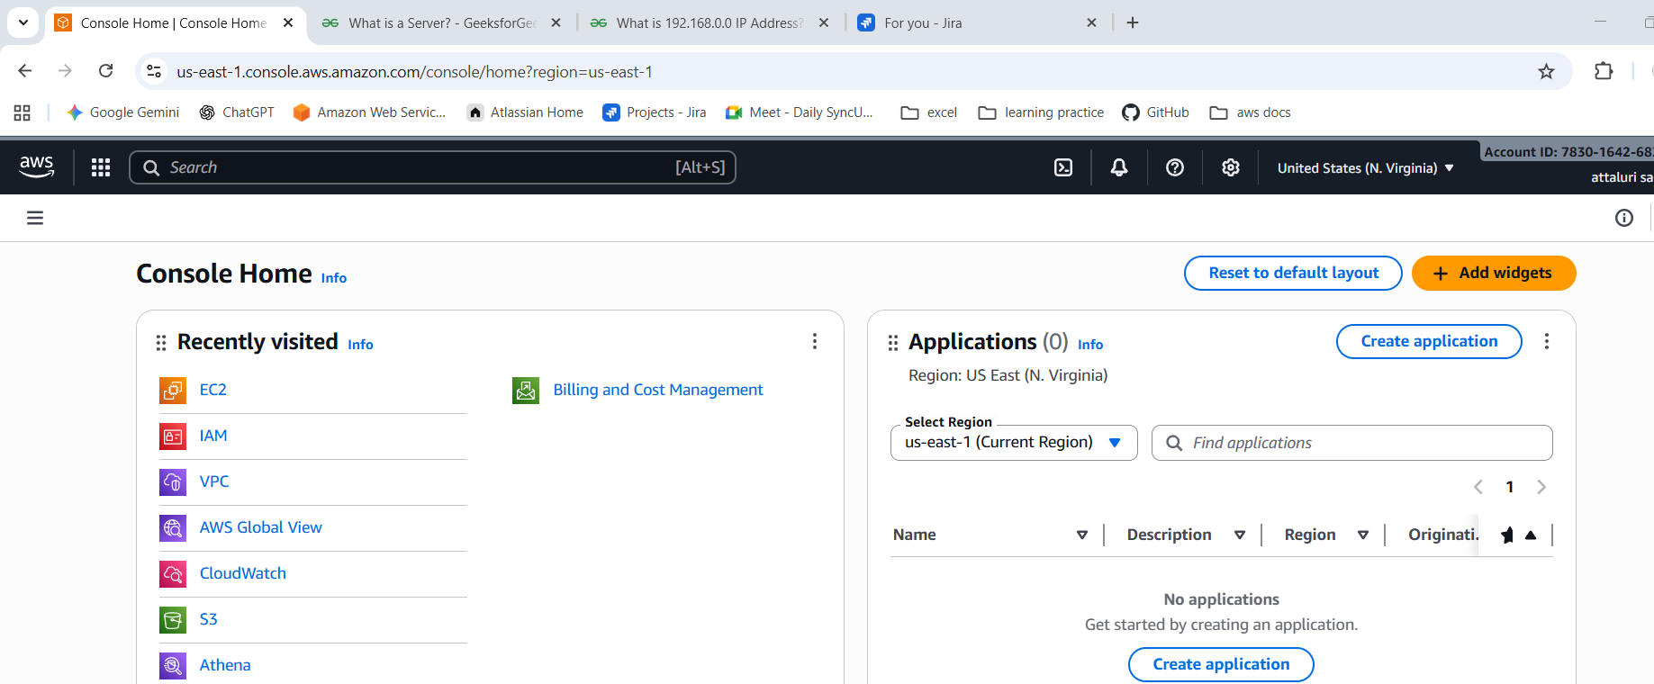
Step 2: Navigate to S3 Resource Option
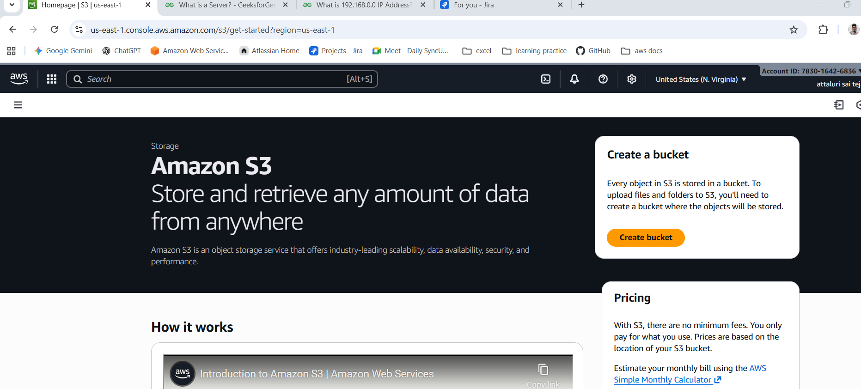
Step 3: Click on Create Bucket to create a S3 bucket with unique bucket name
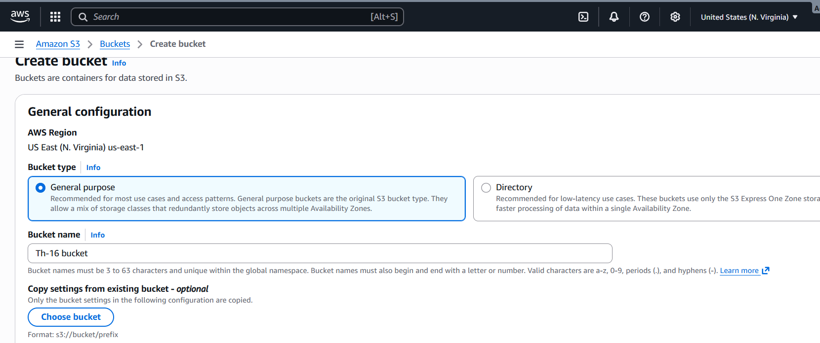
**Note : Name should be unique for the reason it is a Global availability service
Step 4: Leave the options in default and select to create a bucket
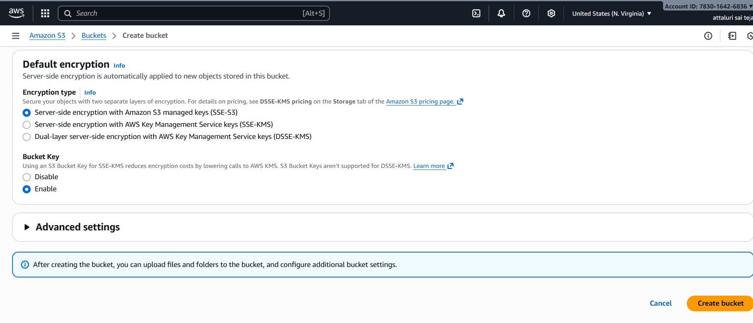
Step 5: Successfully Bucket was created
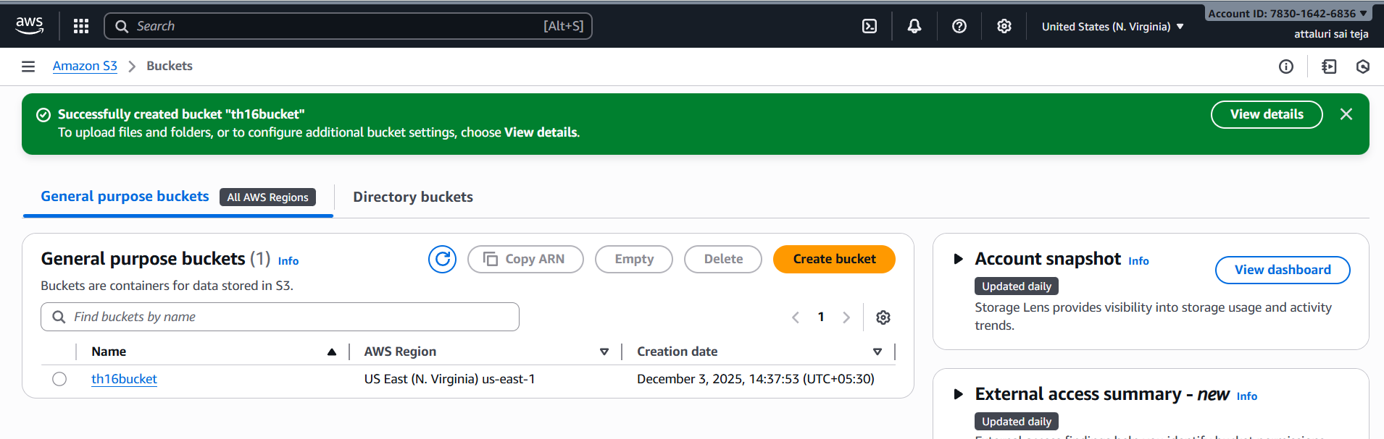
Step 6: Click on the bucket to get inside of it and select upload option to upload the files
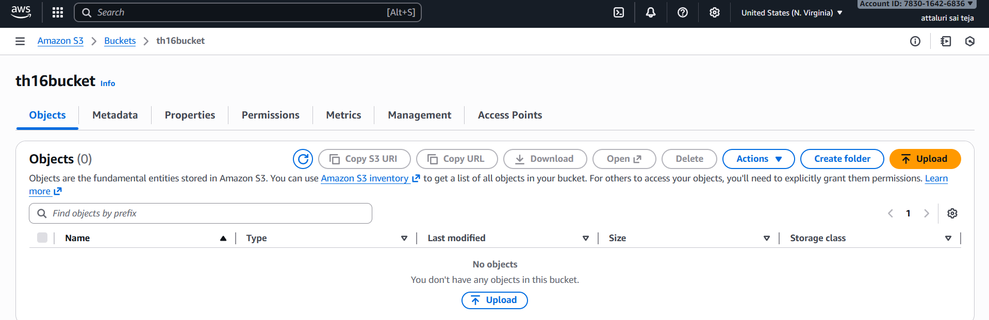

Step 7: Click on add files or add folders to upload the objects
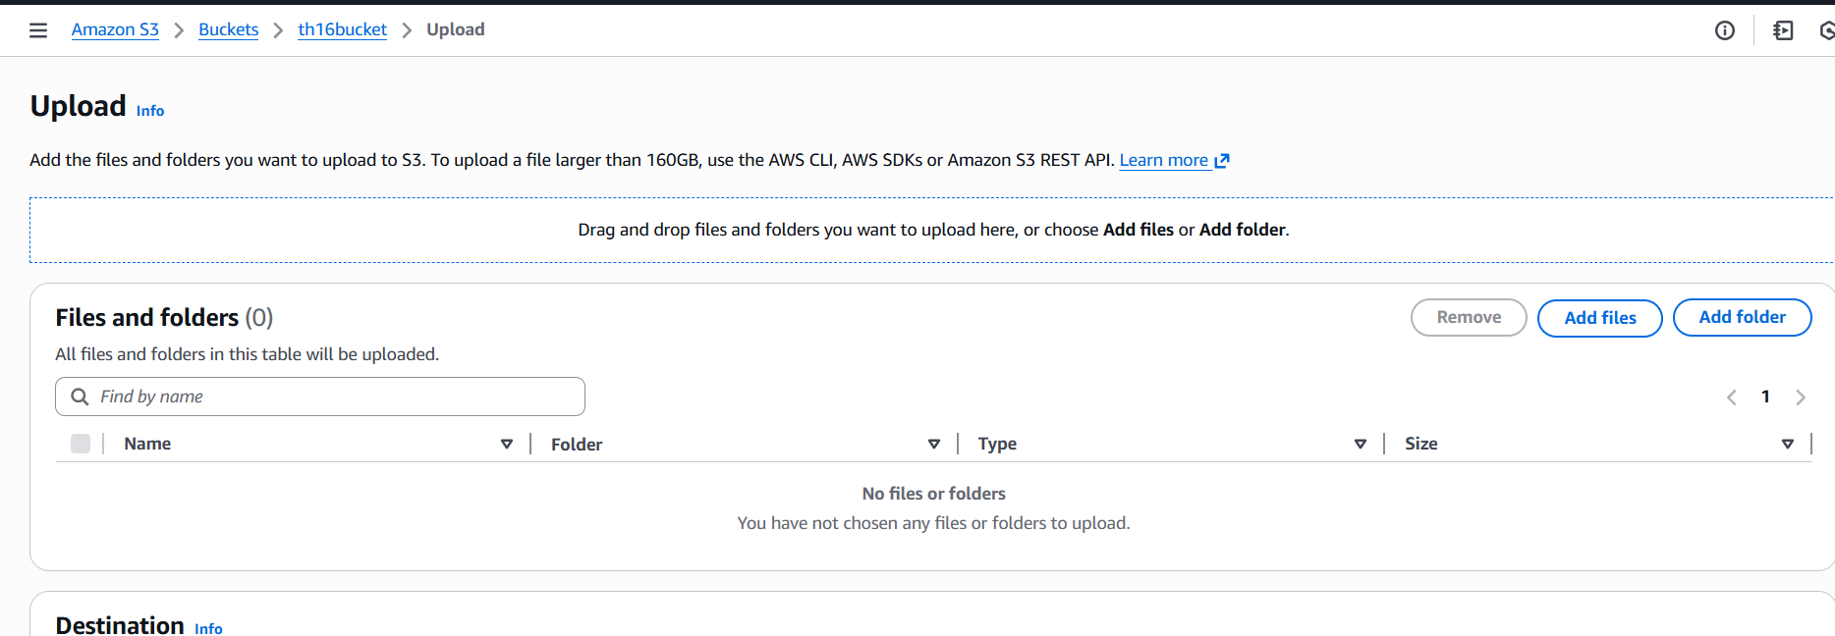
Step 8: Verify the added files and select upload option
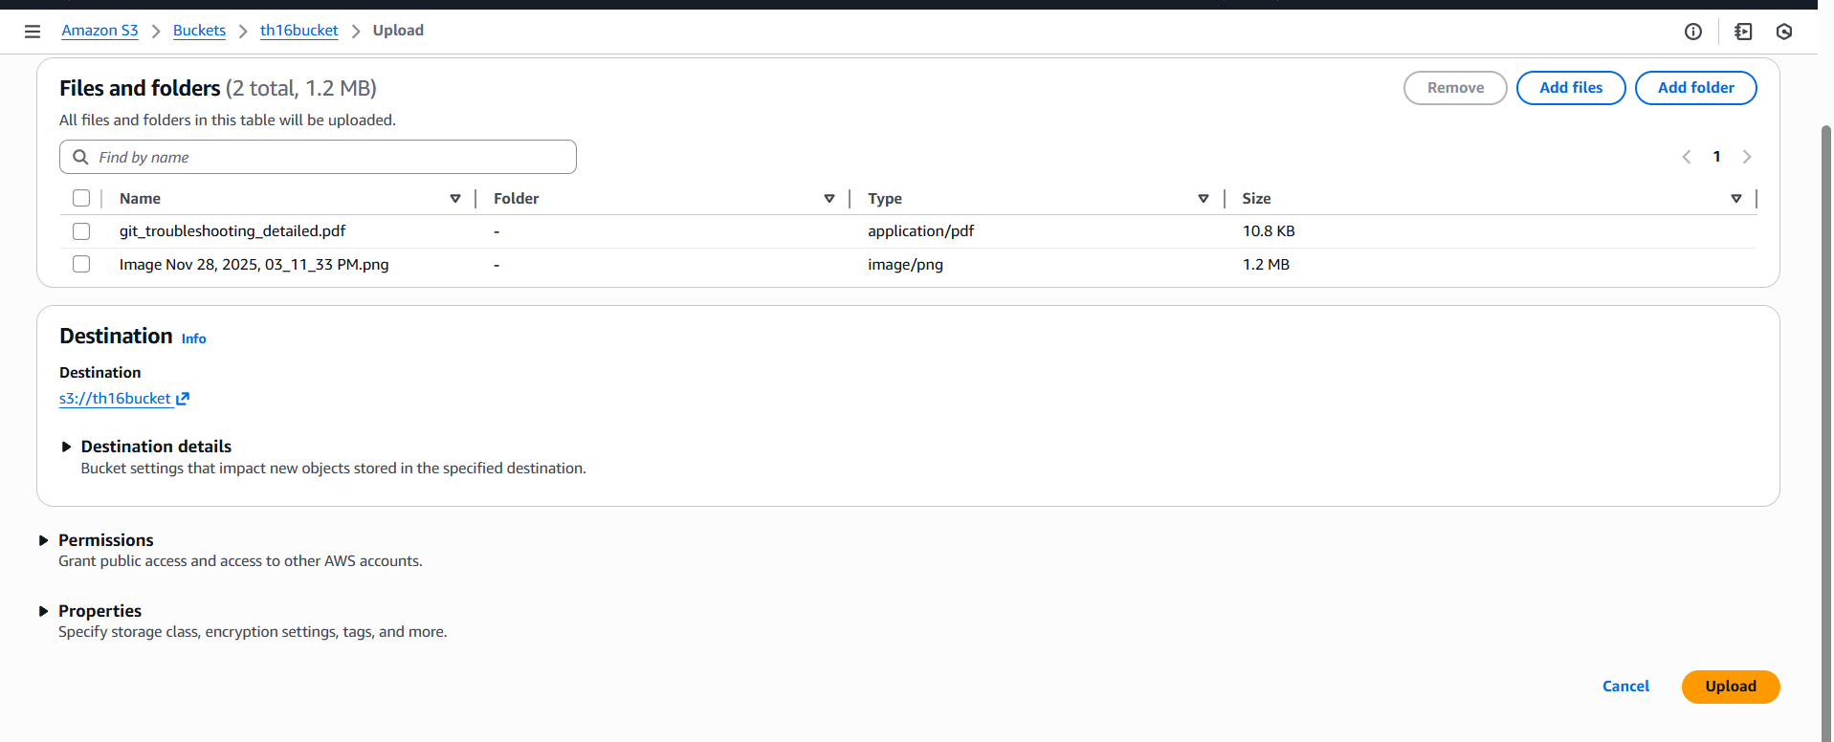
Step 9: Uploaded the objects to S3 bucket
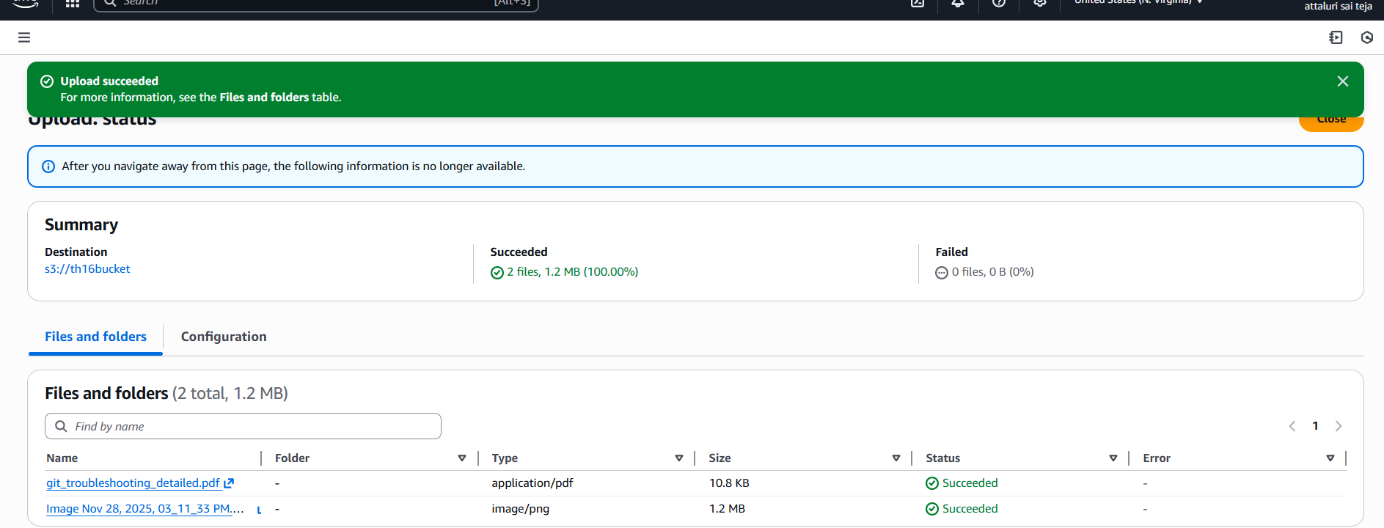

Validation Part
Step 1: Checking Whether objects are uploaded or not
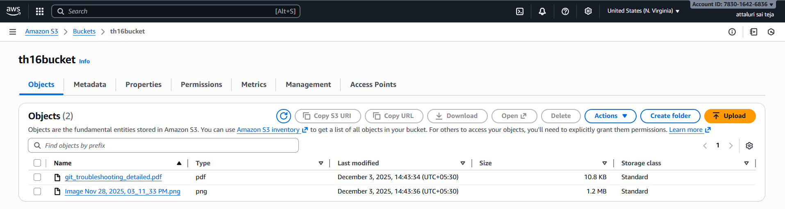
Step 2: Trying to open the objects
By that you will be directed to the object information and copy the link to view the object or image
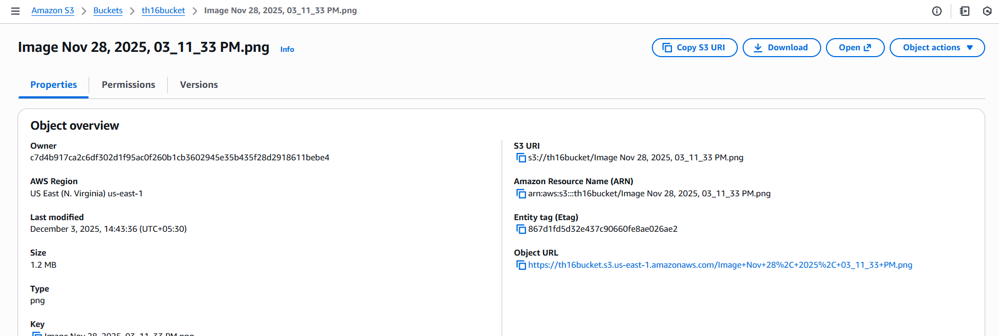
Step3: It denying the request because we didn’t allowed the permissions to view .
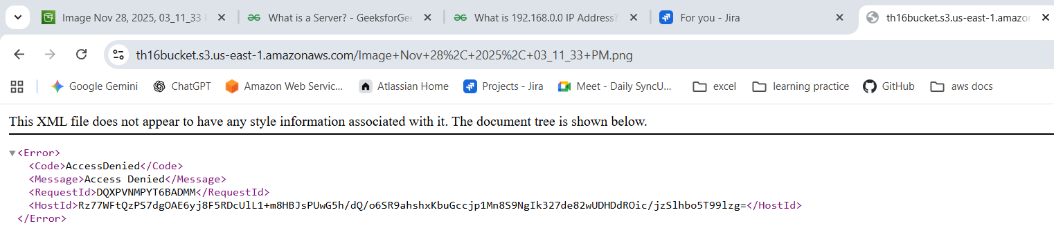

Step 4: Giving the permission to read for public access
Navigate to bucket and click on permissions tab to provide permissions
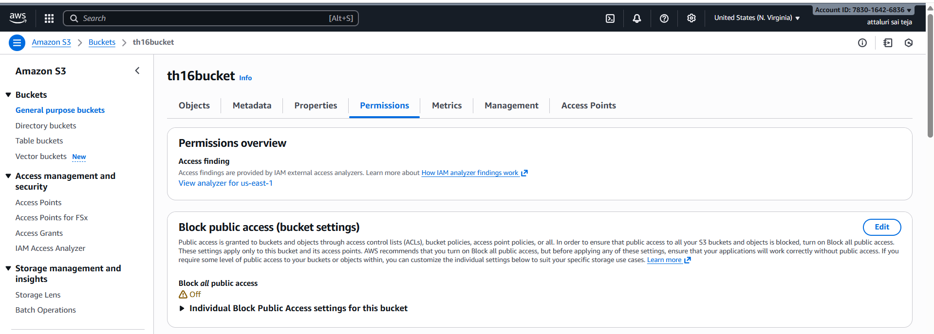
Step 5: un check the space and save changes
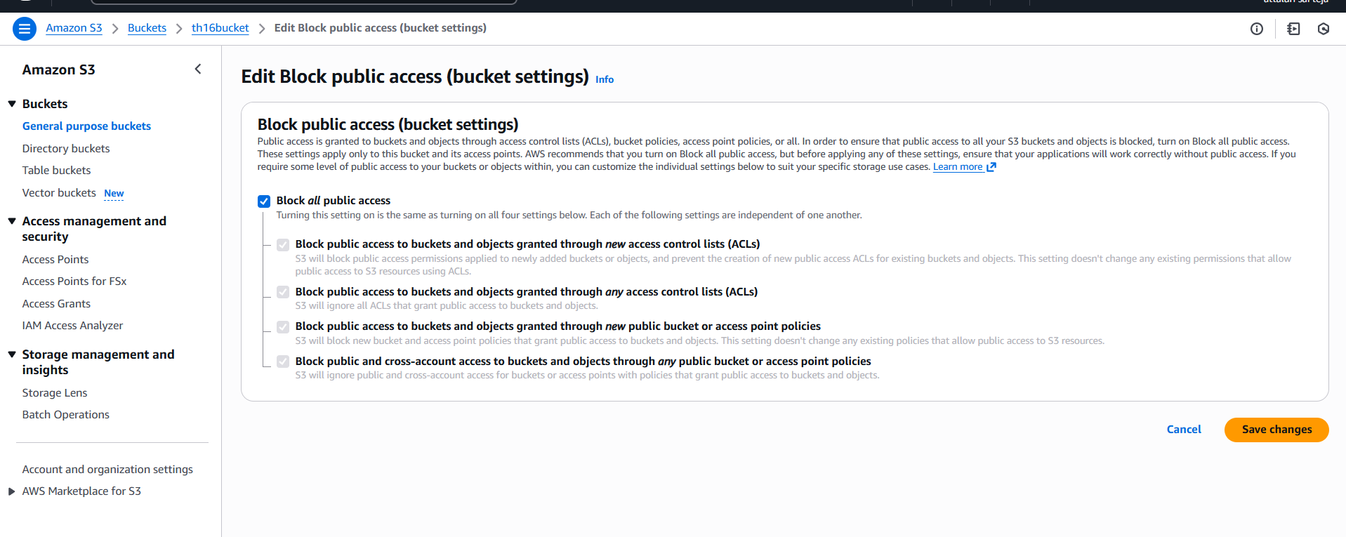
Step 6: Navigate into access control list (ACL) and click on edit to provide permissions
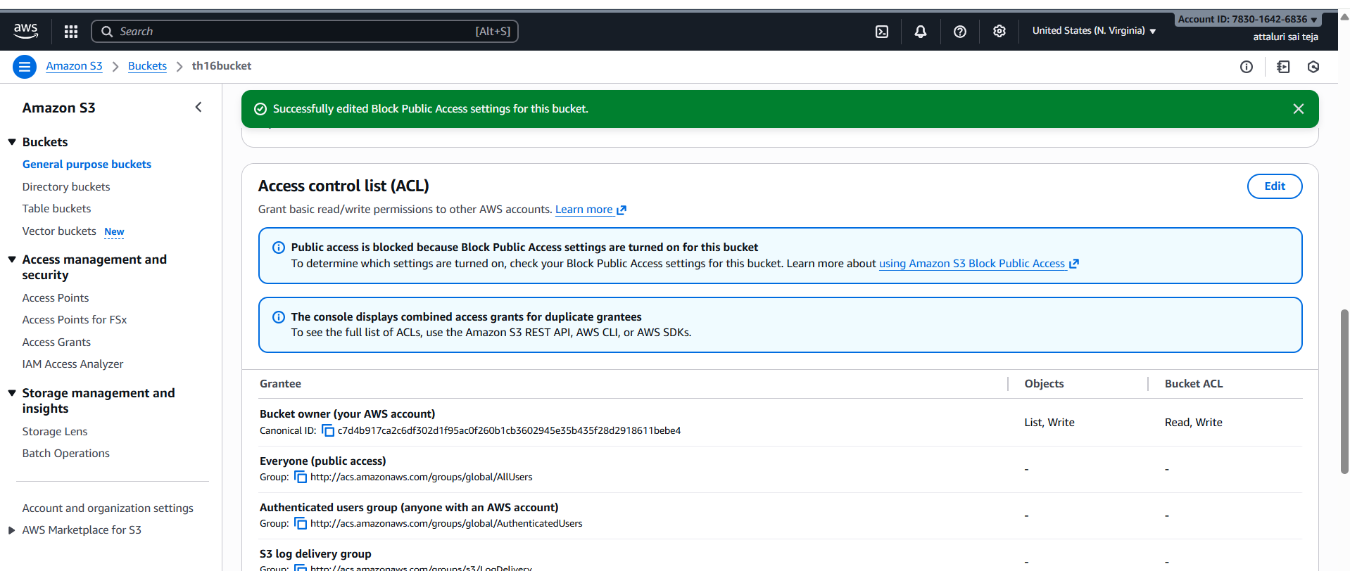
Step 7: Provide the read only access
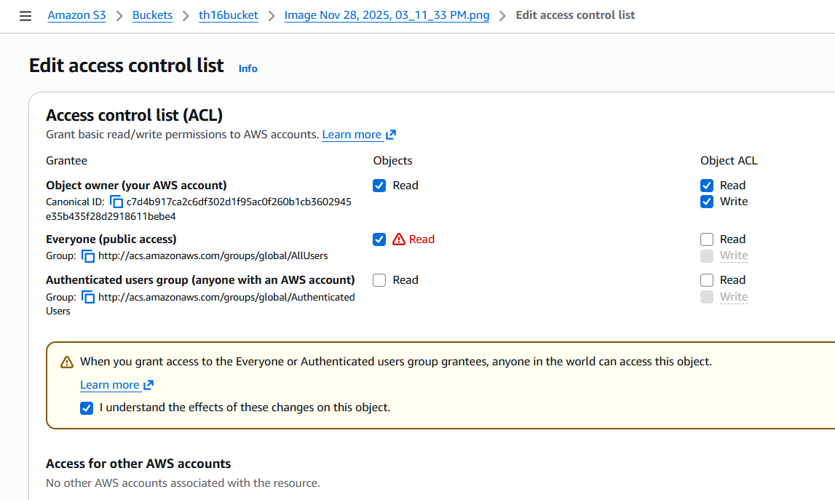
Step 8: Verified on browser using the link
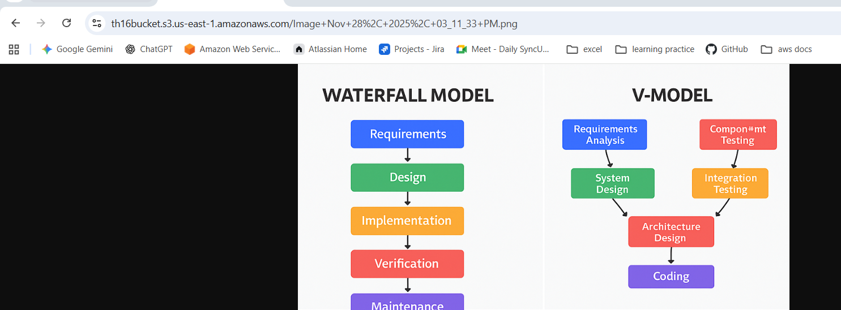

2.Deploy a static website in the S3 bucket.
Step 1: Navigate to S3 bucket and select Properties option
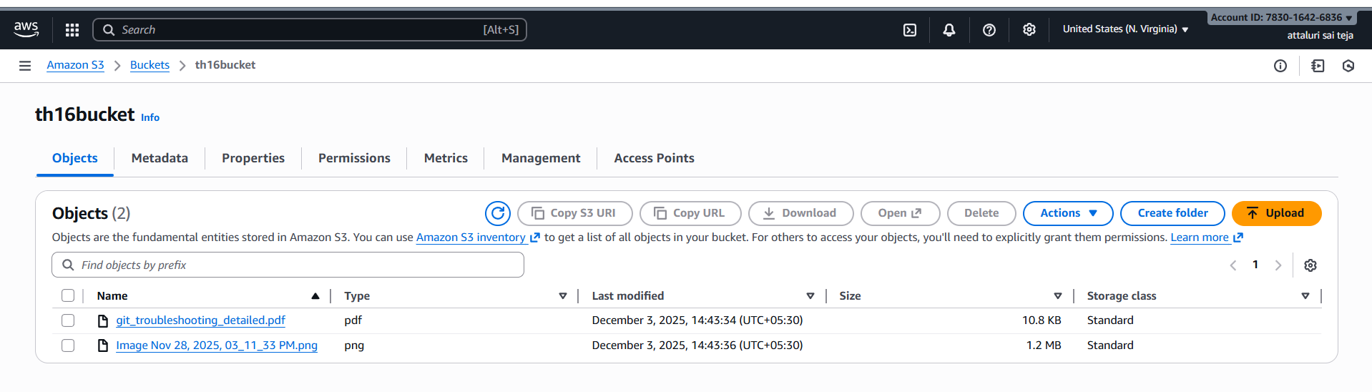
Step 2: Select the option Host a Static Website and click on edit
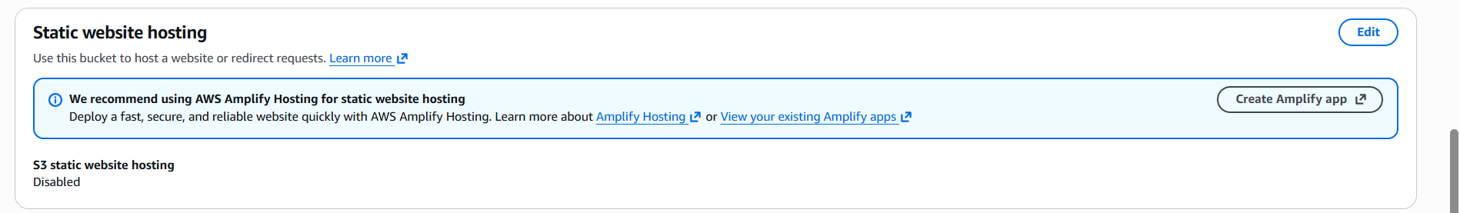
Step 3: Enable the option to continue
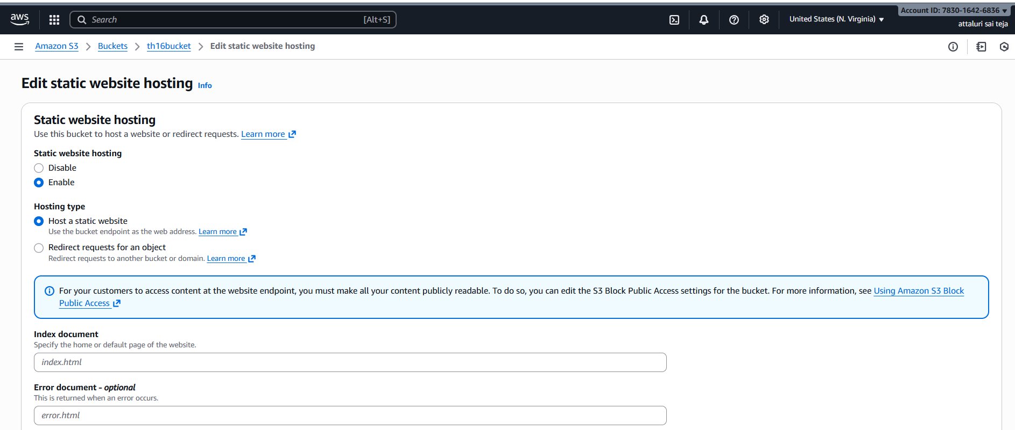

Step4: Create two files called Index.html and Error.html using CLI
Created 2 files and inserted the data into it
Using cat command viewed the data inside of files
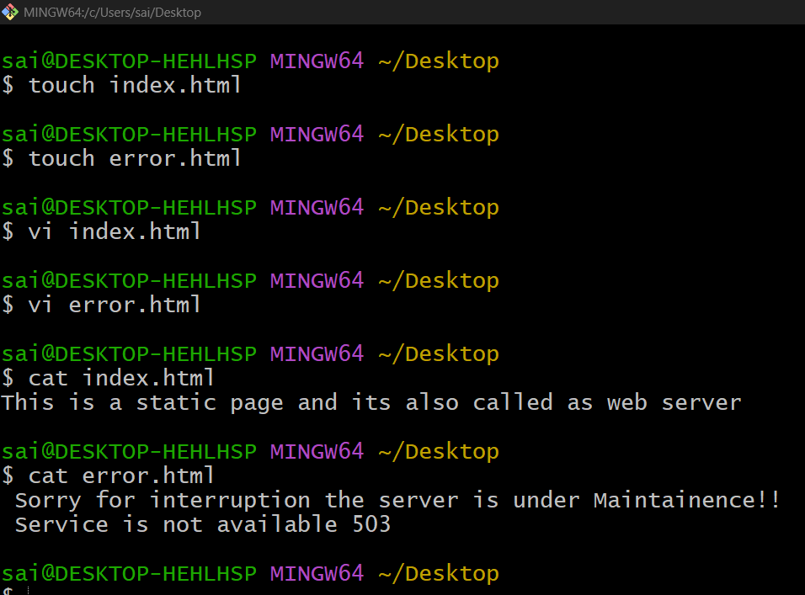
Step 5: upload the files same like earlier in task 1
And navigate into the file and select actions button and select acl permissions
And select make object as public , do same for other file
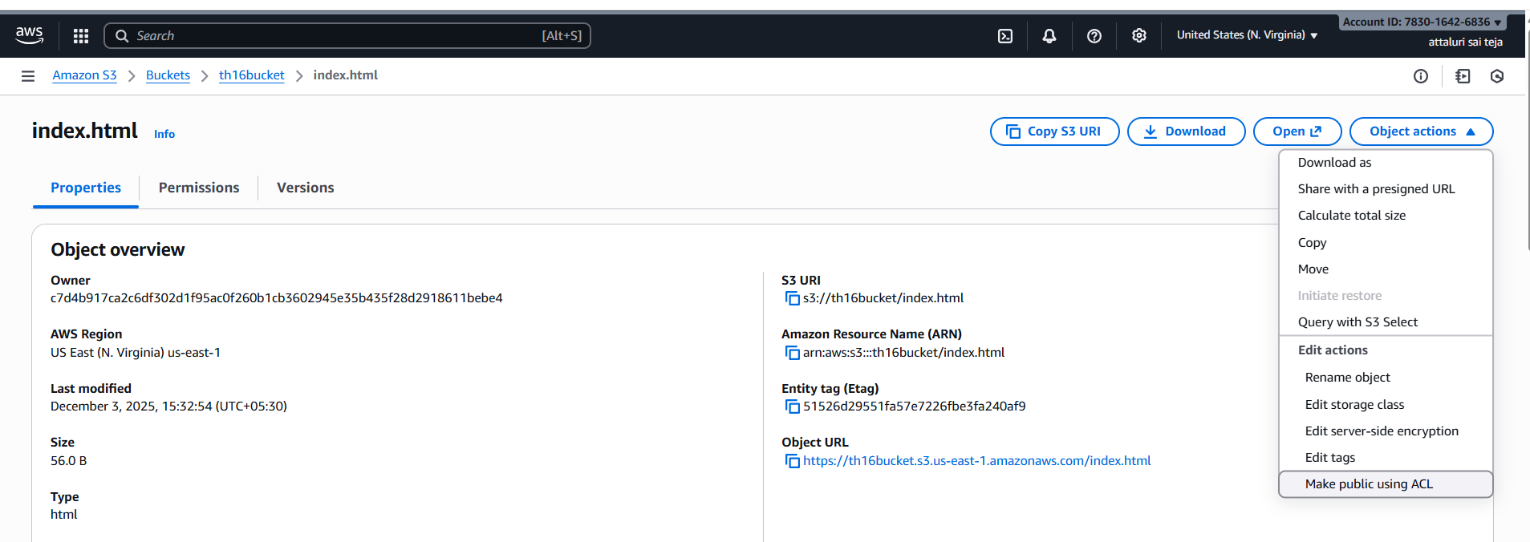
Step 6: Enter the file names of you created earlier using CLI
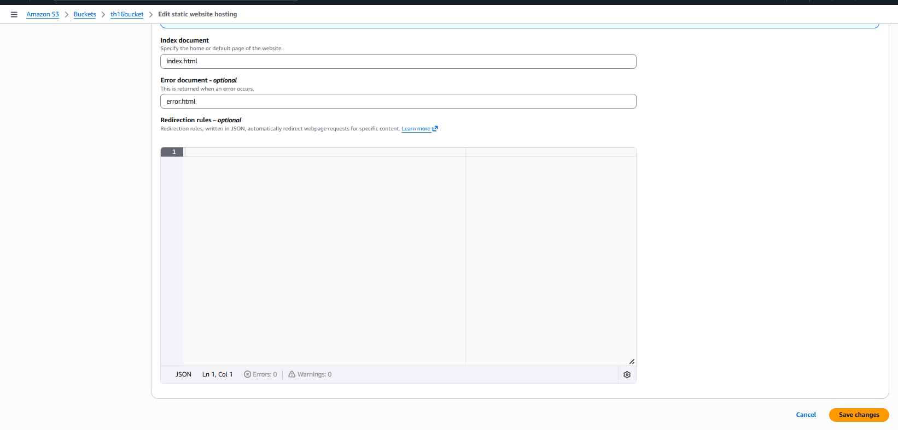
Step 7: Hosted a website Successfully
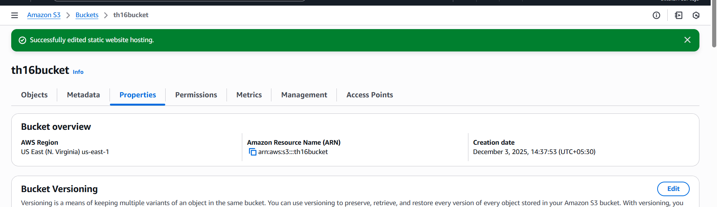
Validation Steps
Step 1: Verifying the Website is available or not
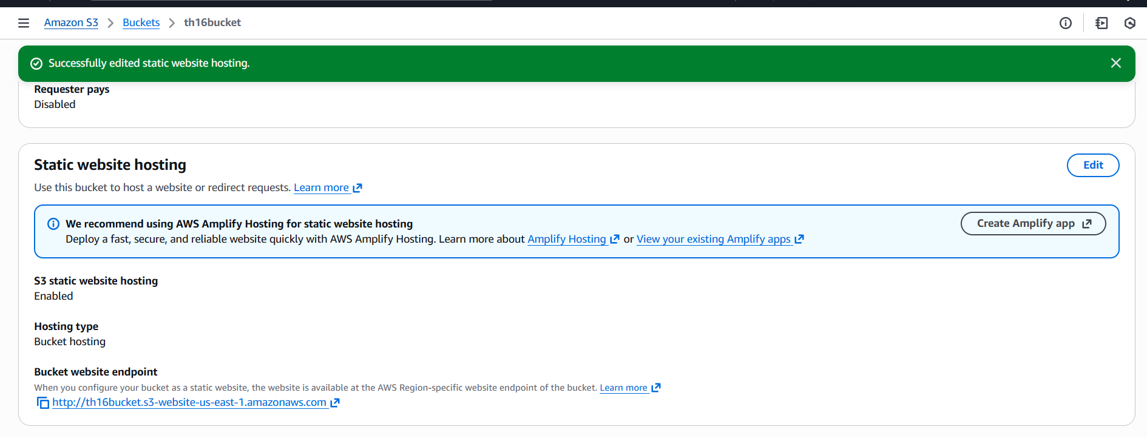
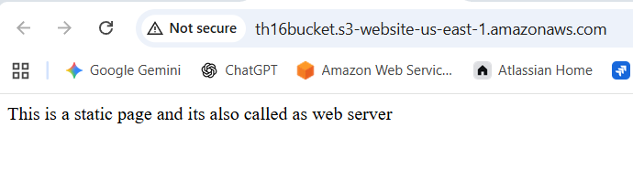
If we need to get the error message then delete the file from s3 bucket and refresh the link.
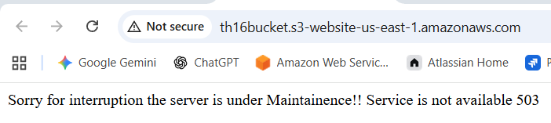

- Enable cross-region replication on S3 buckets.
Step 1: At first we need to create s3 buckets in two regions
(we need two buckets in two regions)
Myself already having a bucket in one region and im creating other in another region
- North virginia region
- Mumbai region
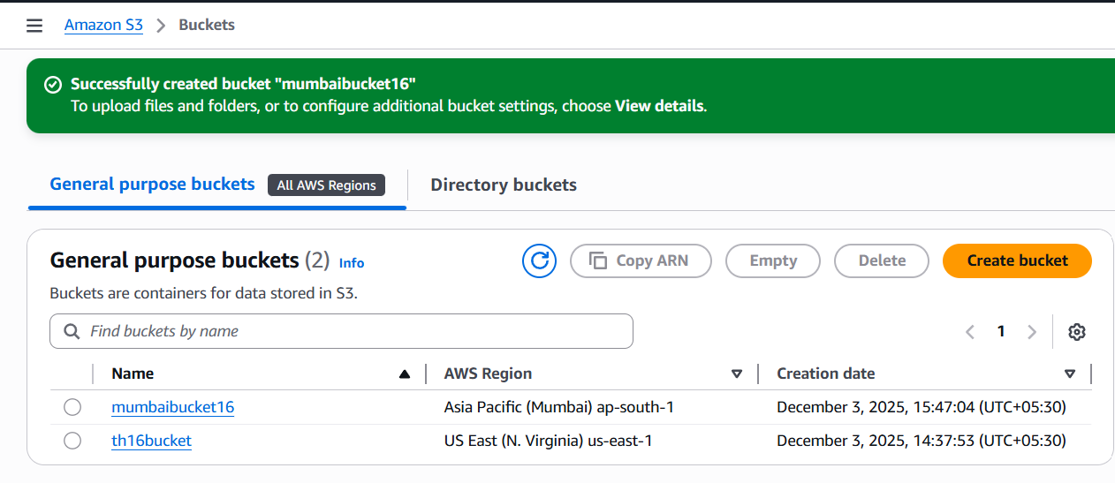

Step 2: Navigate to Replication rules section and click on create replication rule from n.virginia region and we will connect to Mumbai region

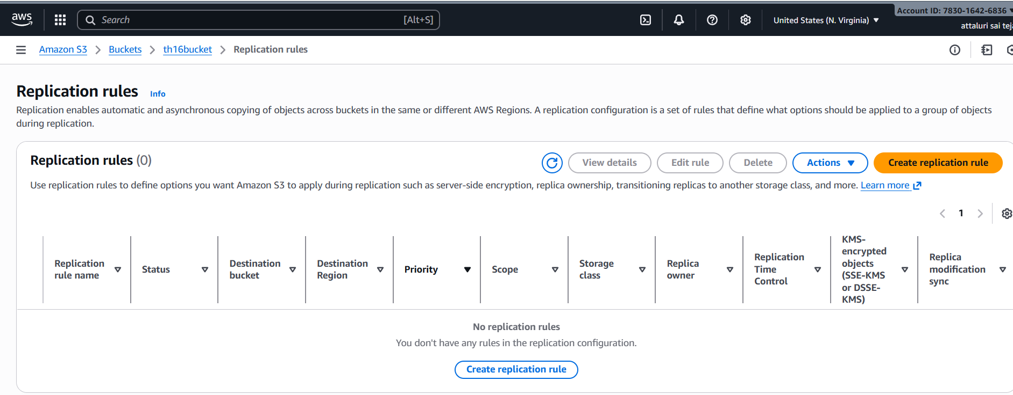
Step 3: give the rule name enable the options
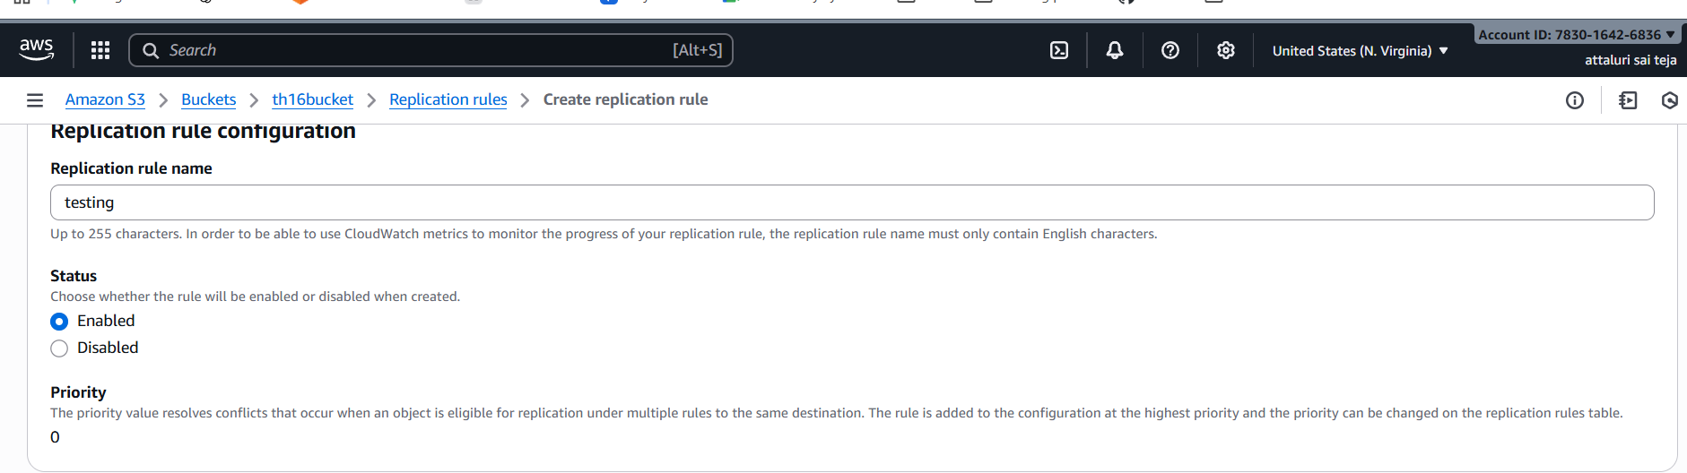
Step 4: select the listed options APPLY TO ALL OBJECTS IN THIS BUCKET
And enter the bucket name or choose the bucket name
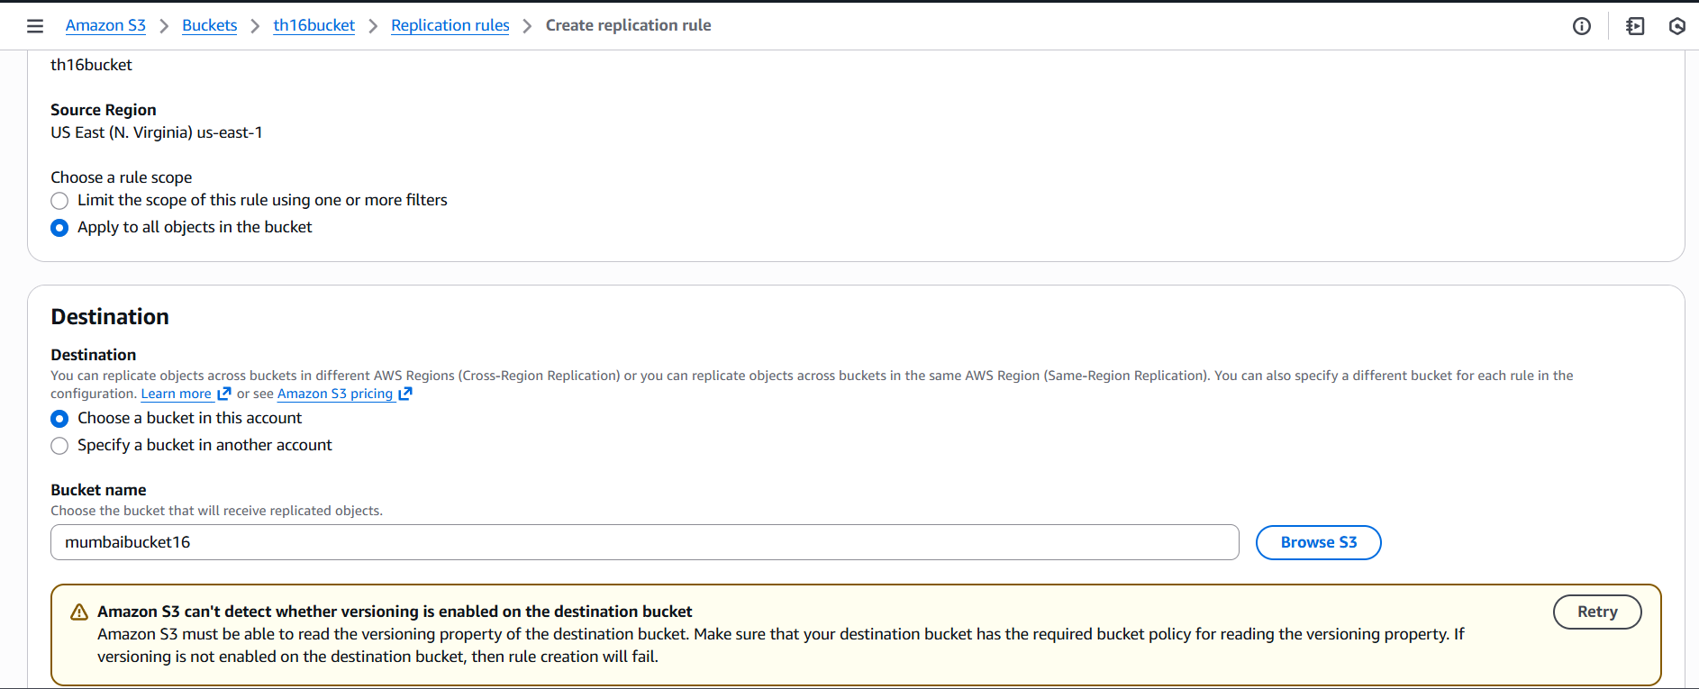

Step 5: Select an option to create IAM role and continue
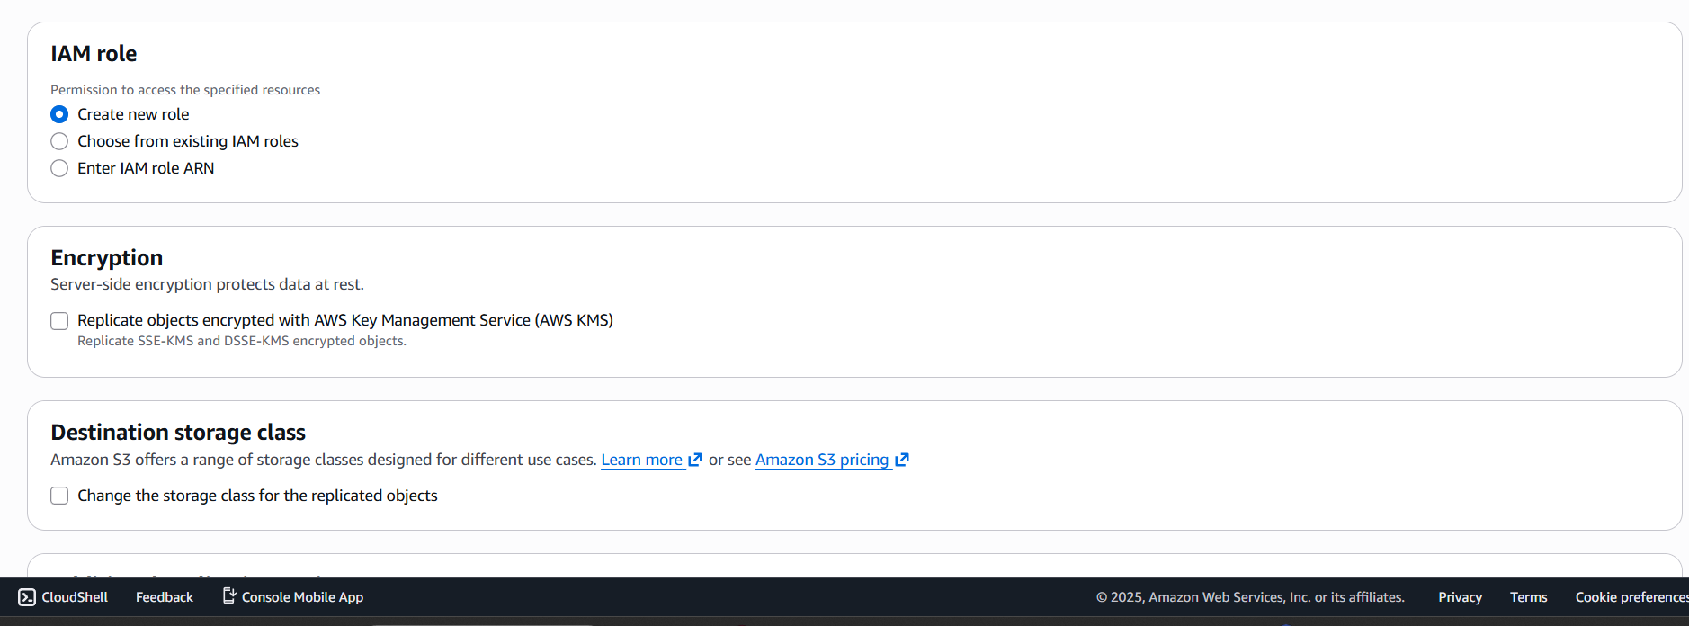
Step 6: Successfully Created
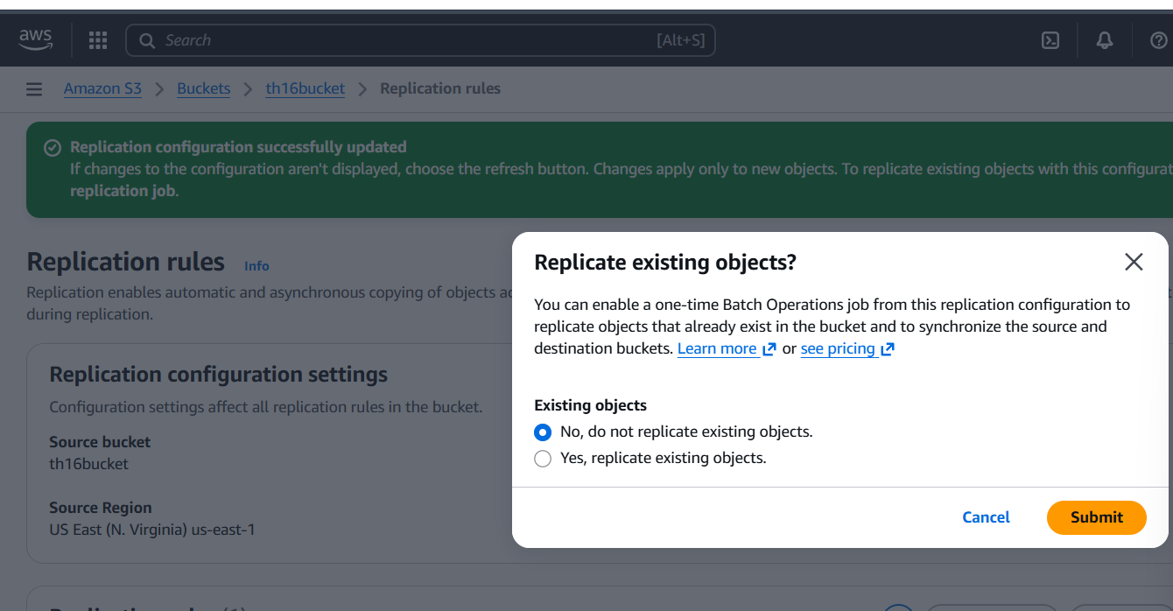
Validation Steps:
Step 1: selecting to replicate existing objects from the above picture
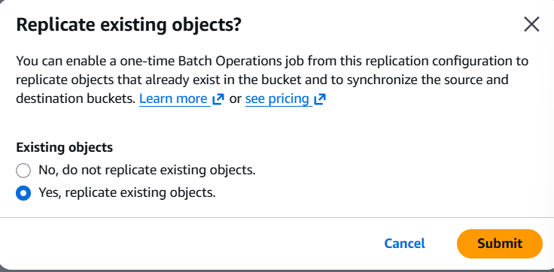
Step 2: Navigate to Replication rules section and select on create replication job
process
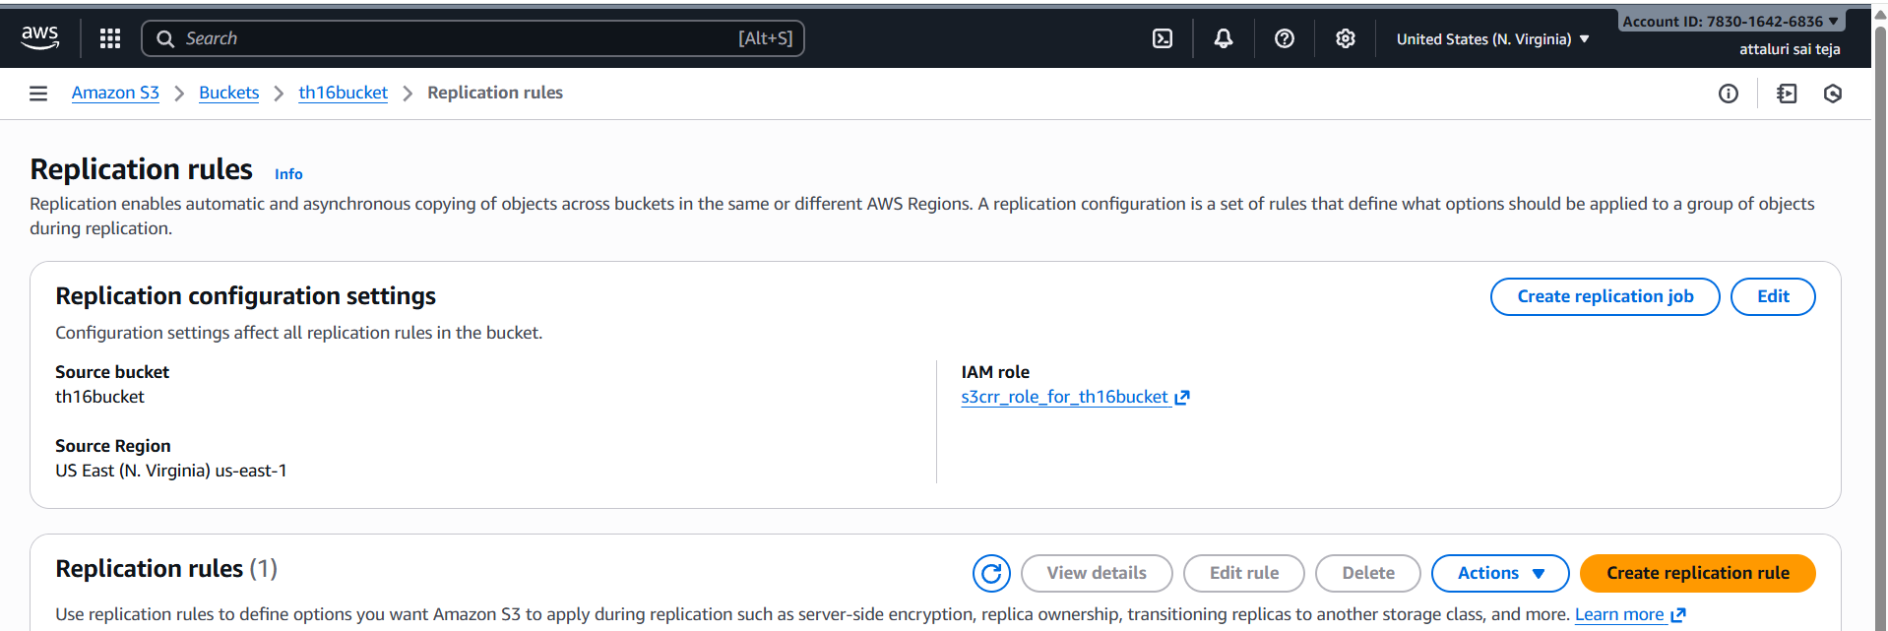
Step 3: Proceed and Continue with default options
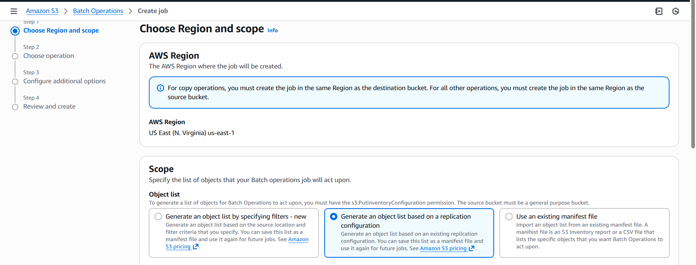
Step 4: Select the source account and continue
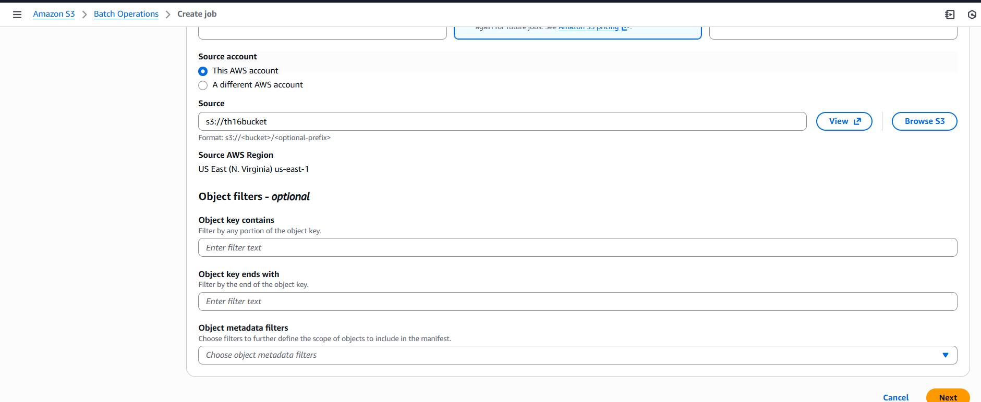

Step 5: Choose the operation type REPLICATE
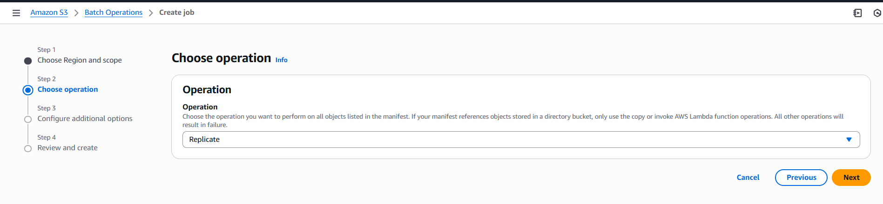Step 6: Review the settings
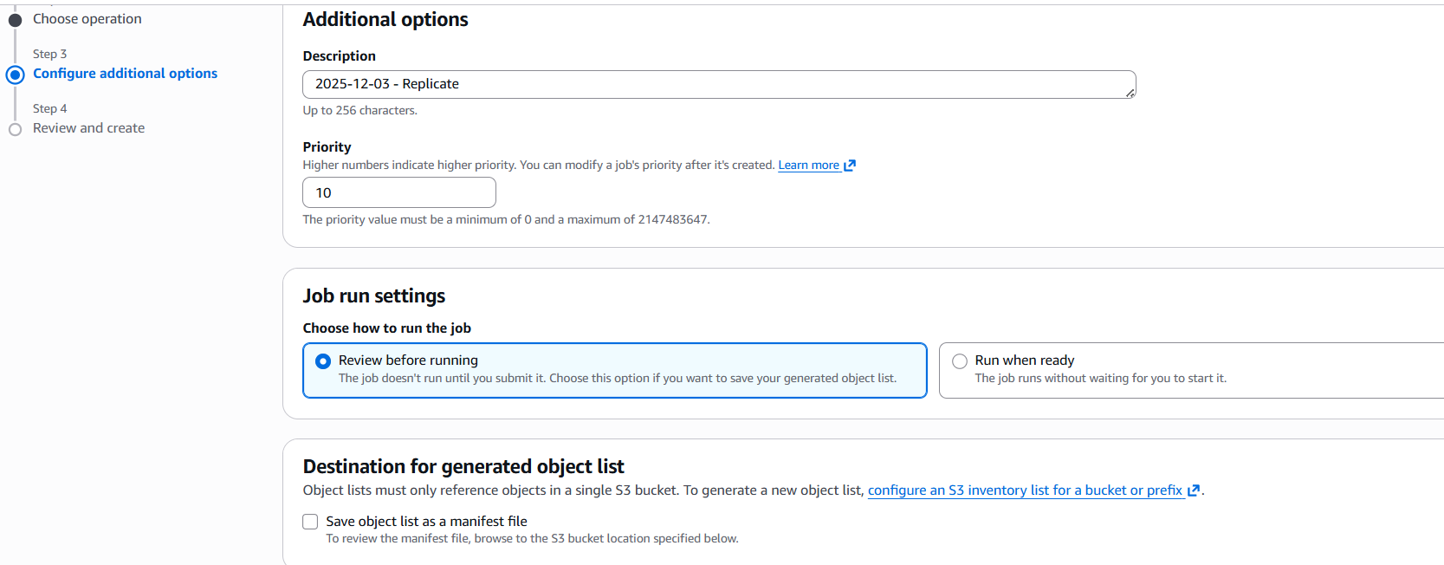
Step 7: Select the different options and select the source bucket name
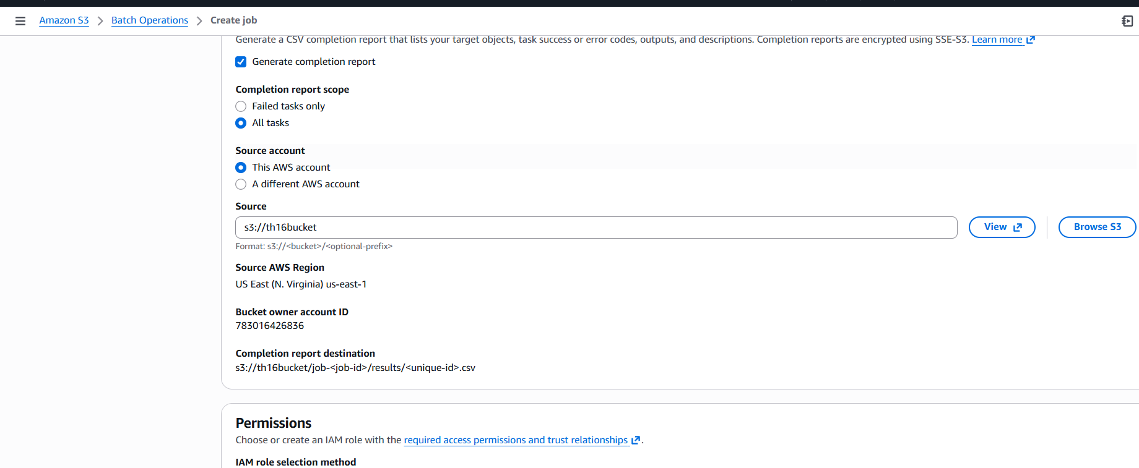

Step 8:Select an option to CREATE IAM ROLE and continue to next
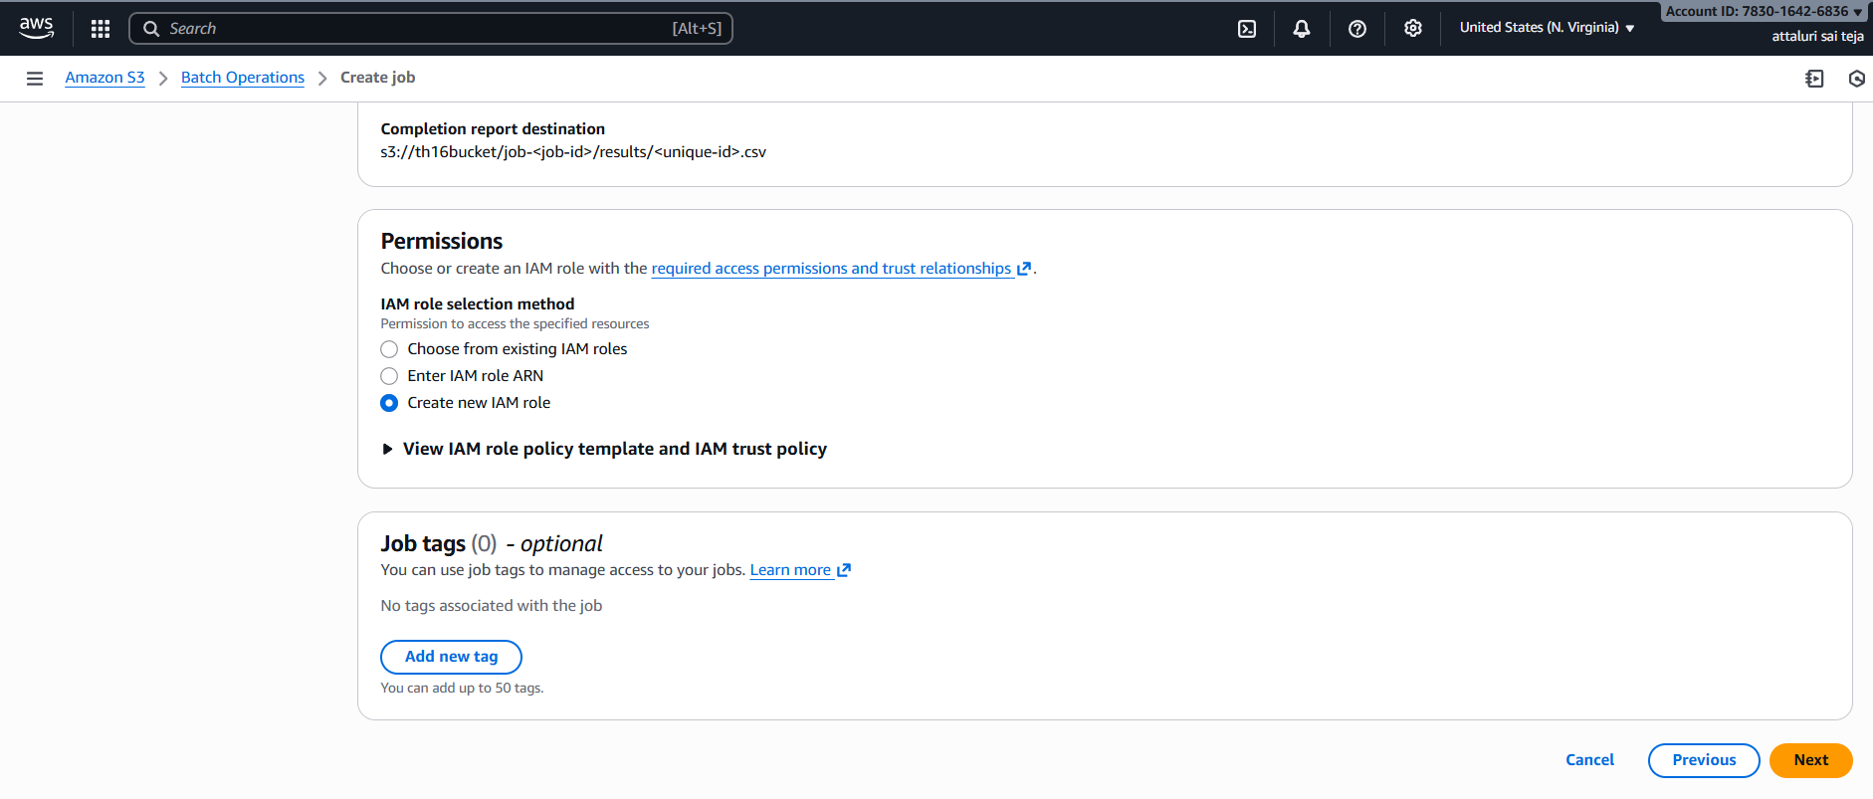
Step 9: Review the details and click on submit
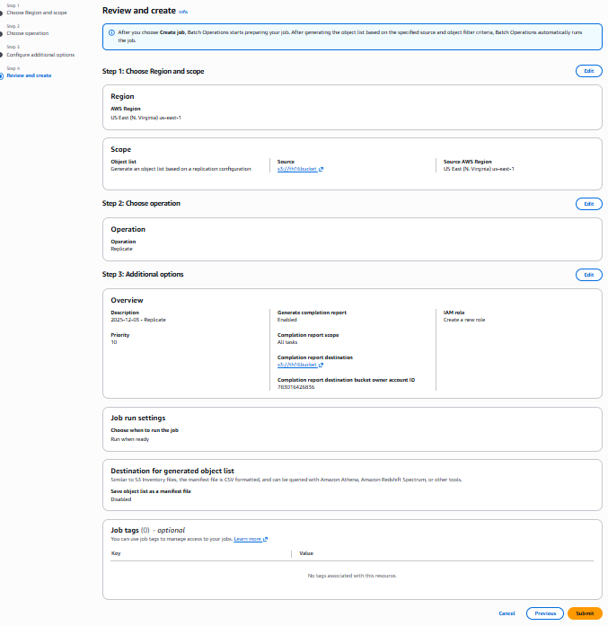
Step 10: Replication Job has been created
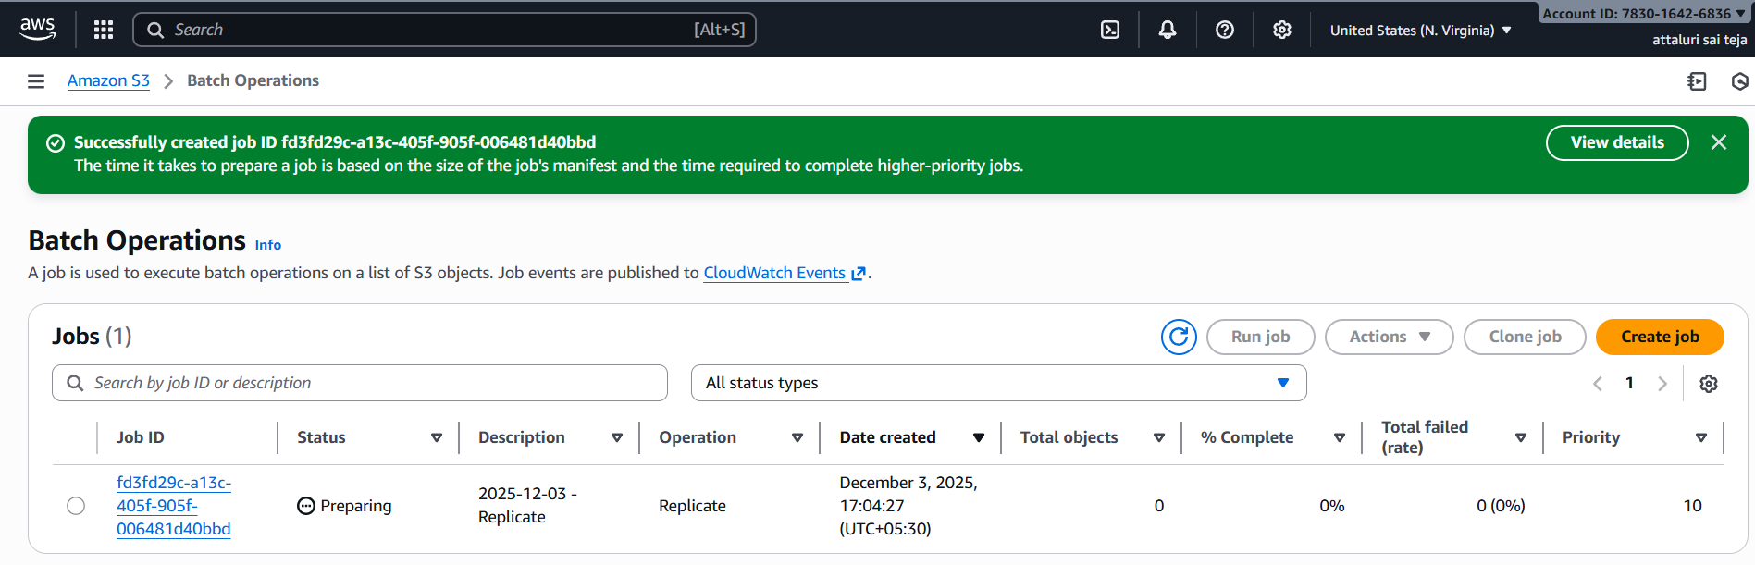
Step 11: Job has done completed
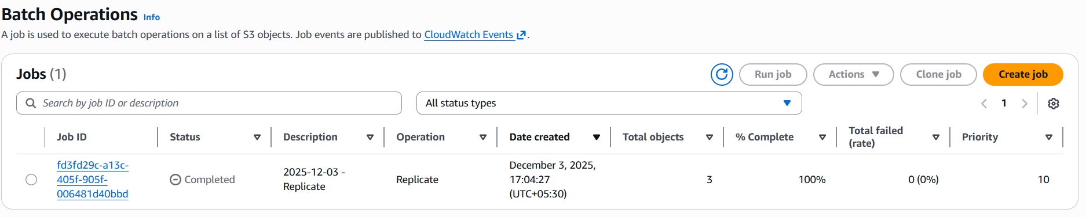
Step 12: verifying the objects in both buckets
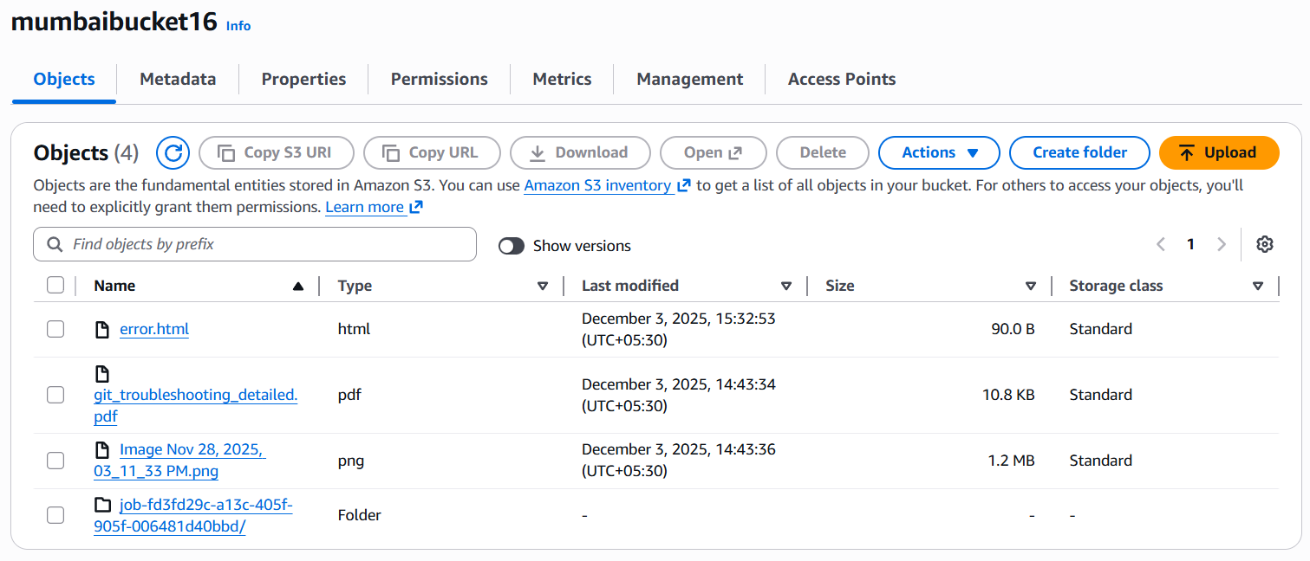
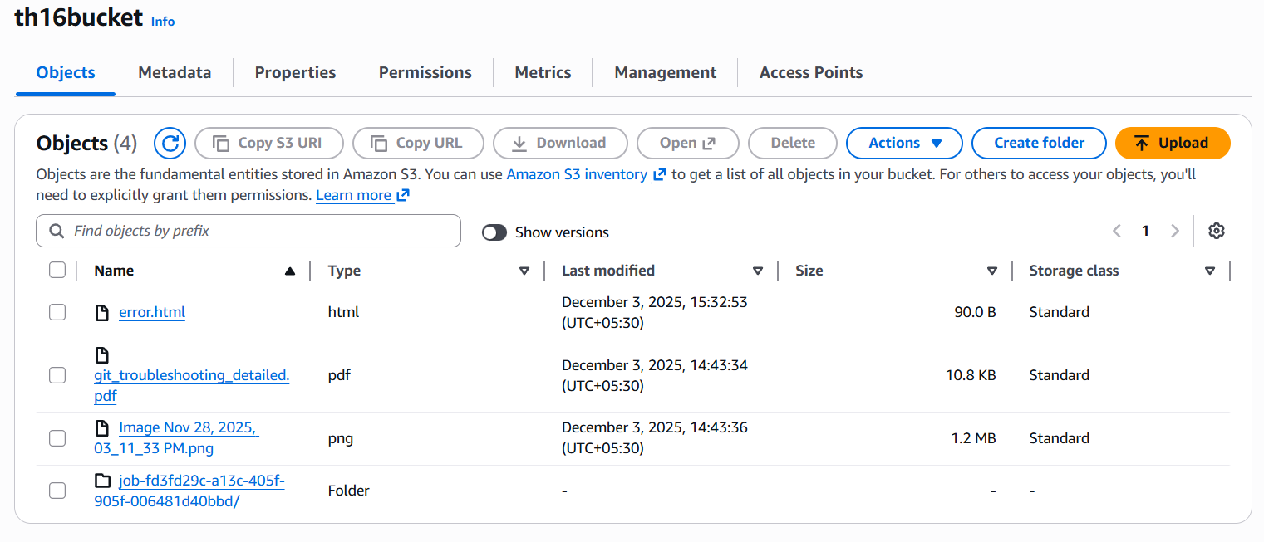
4.Configure a bucket policy so only the Admin user can see the objects of the S3 bucket.
Step 1: Create a IAM user naming ADMIN and Provide S3full access
Navigate to IAM and select IAM user option to create
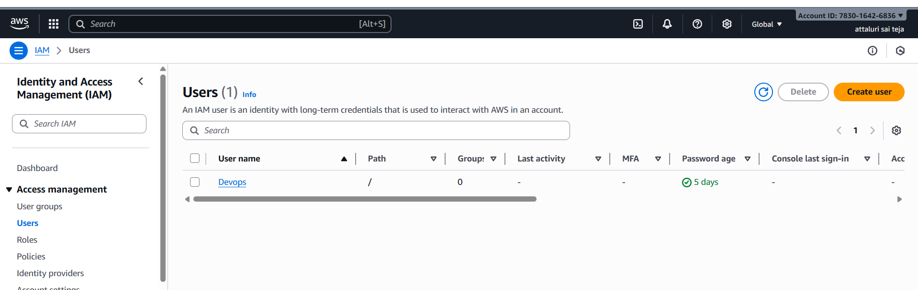
Step 2:Provide the password and continue to next
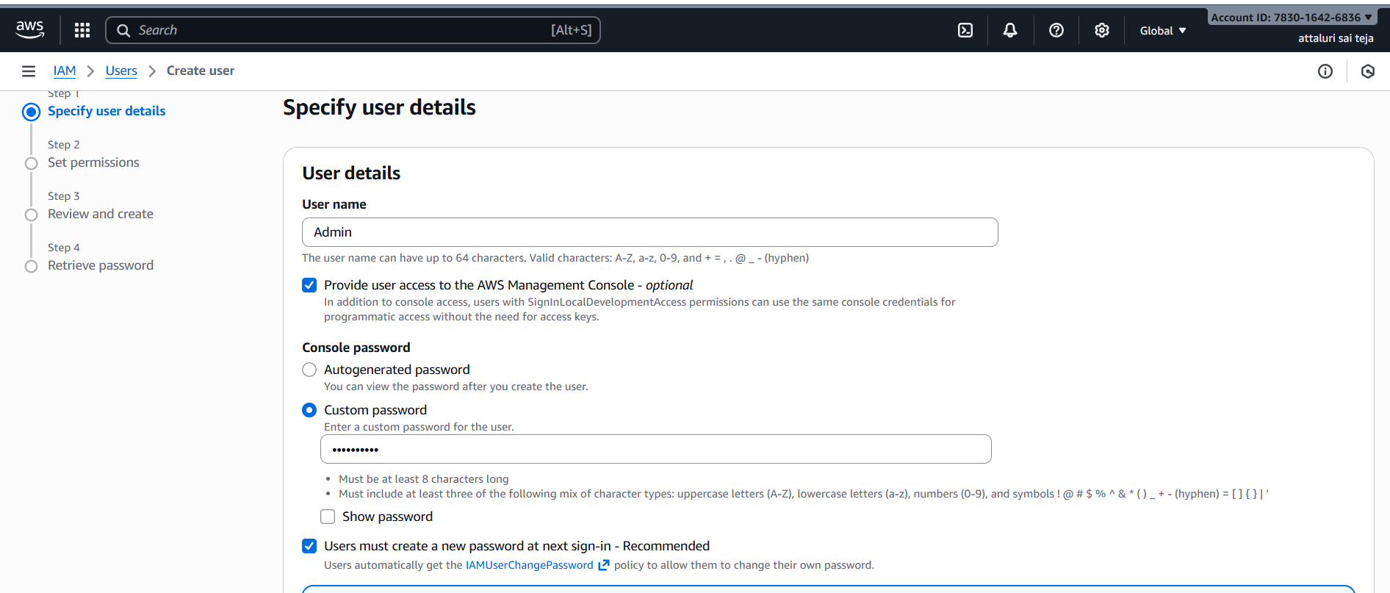
Step 3:Attach a Policy Directly (S3 Full access)
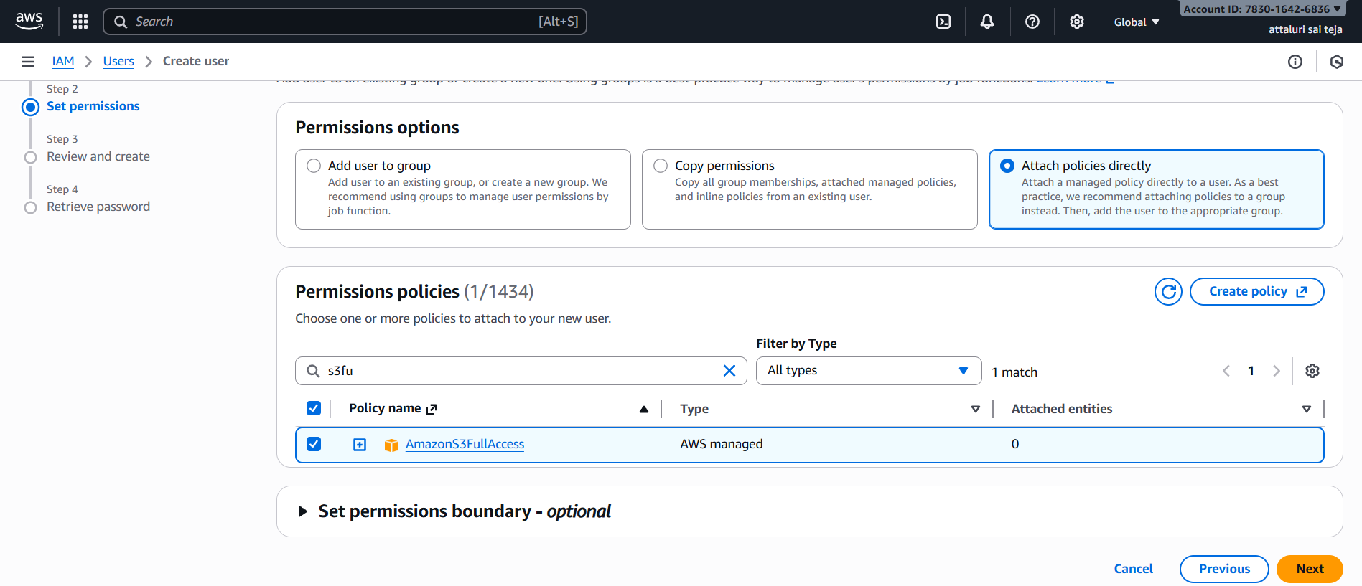
Step 4:Review the name and policies and click on create user
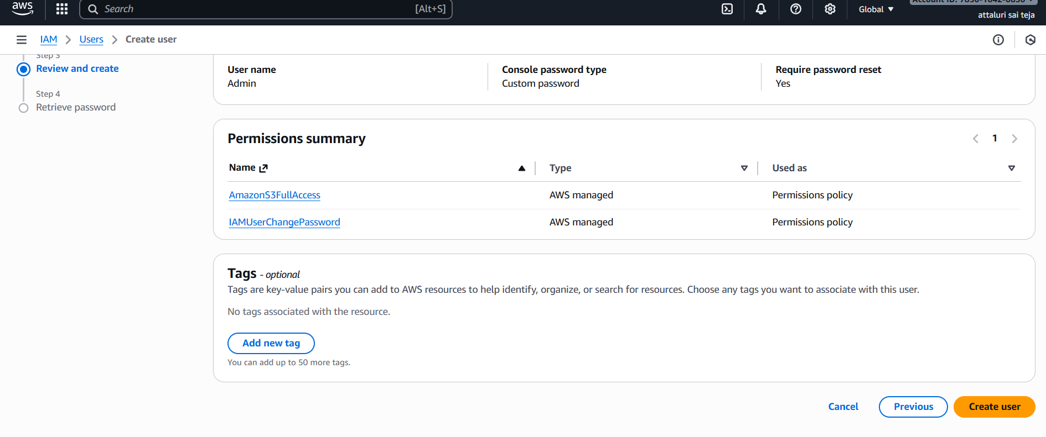
Step 5: User Successfully Created and copy the login details
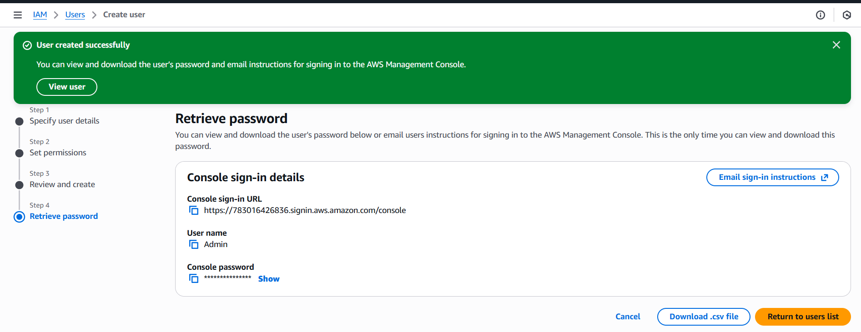
Step 6: Navigate to S3 and go to bucket and select permissions tab and provide JSON script to allow access to Only ADMIN user and deny all others
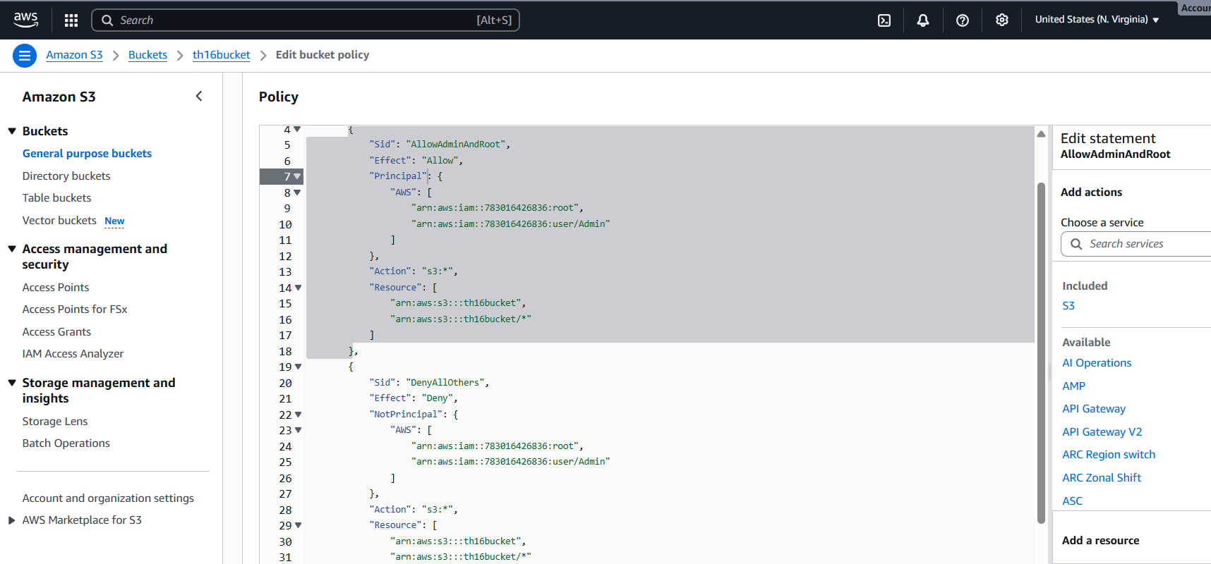
Step 7: Successfully Policy has been created
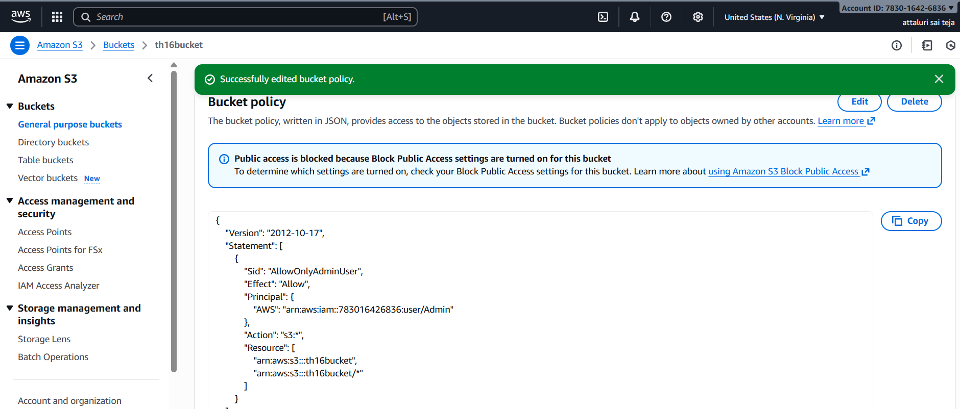
Step 8: Login to IAM user and access S3
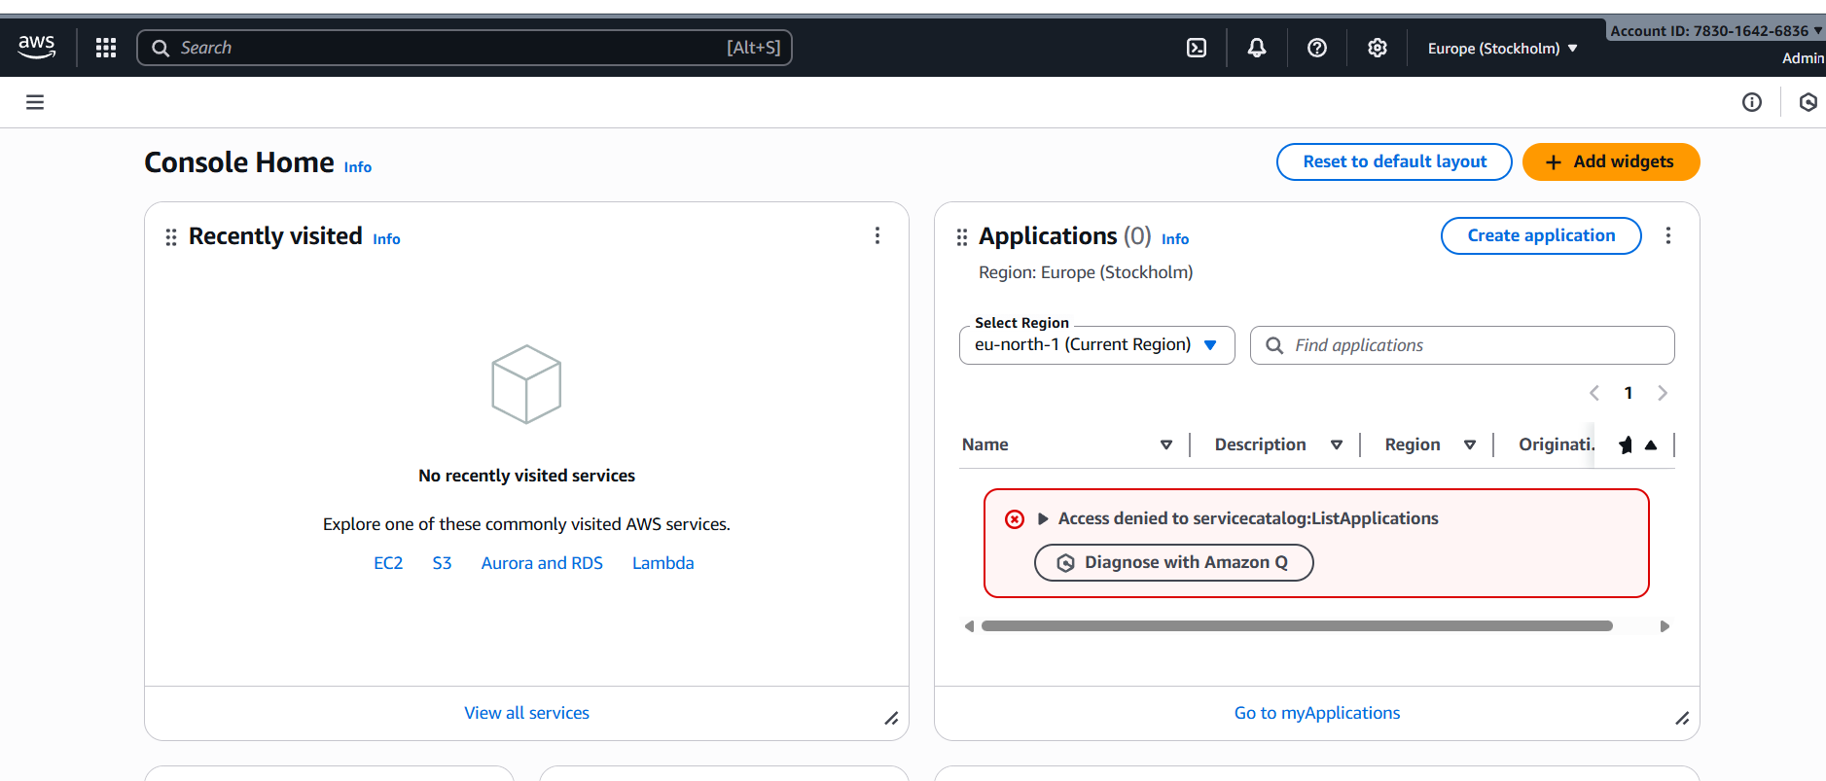
Step 9: The user is able to access the buckets
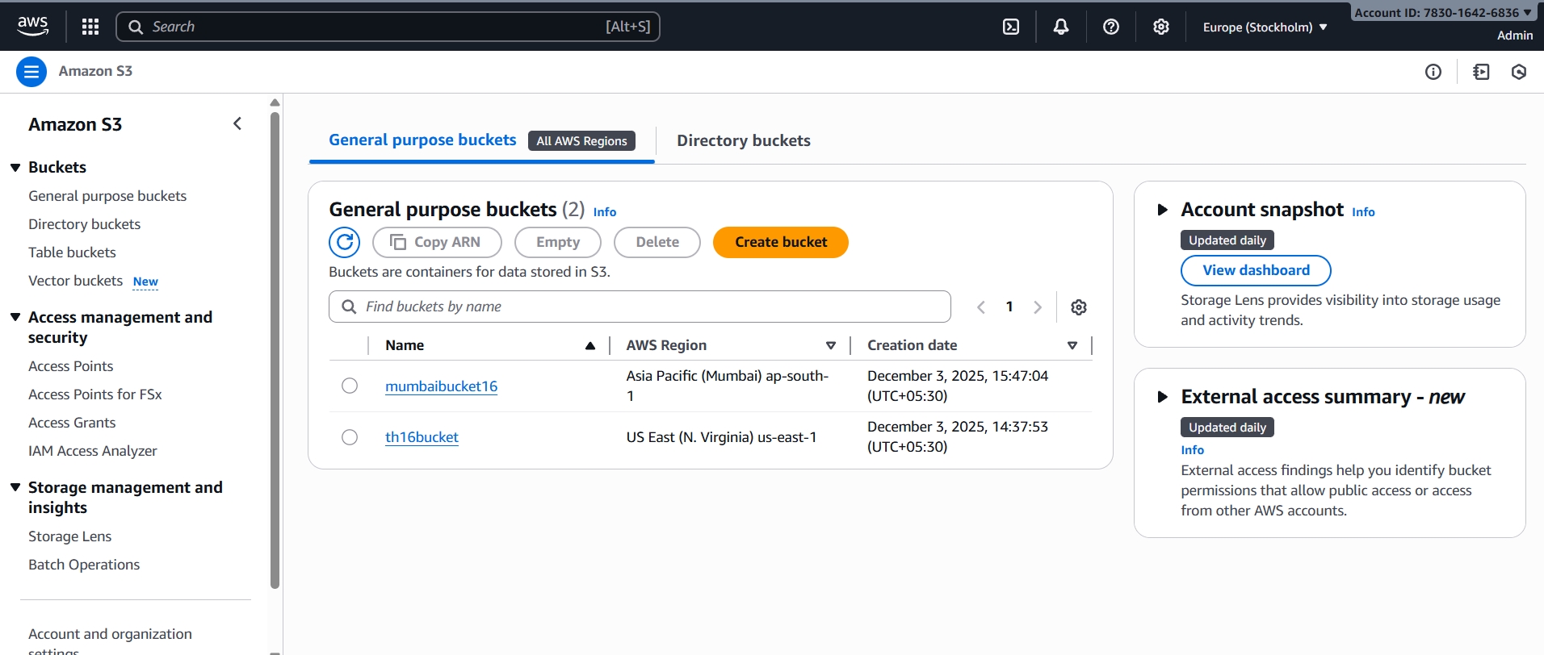
Step 10: The user also able to access the objects inside the bucket
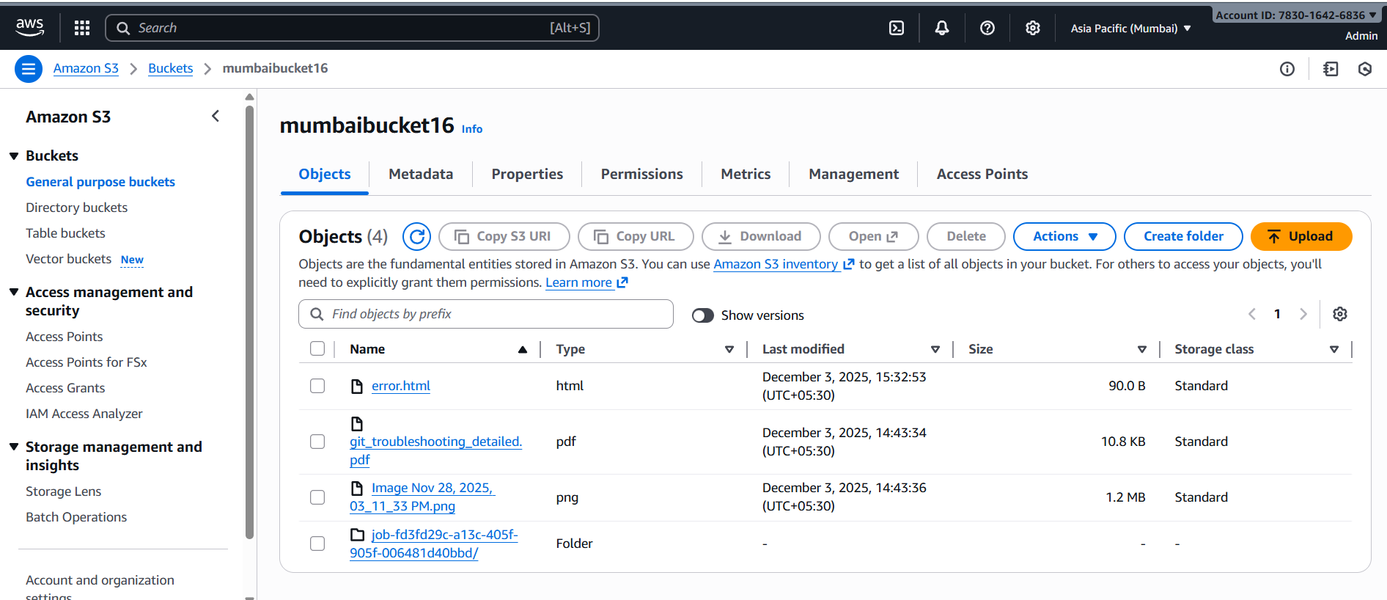
VALIDATION STEPS:
We provided the access to ADMIN user only lets validate another IAM user can access the resource or not
Step 1: Create another IAM user
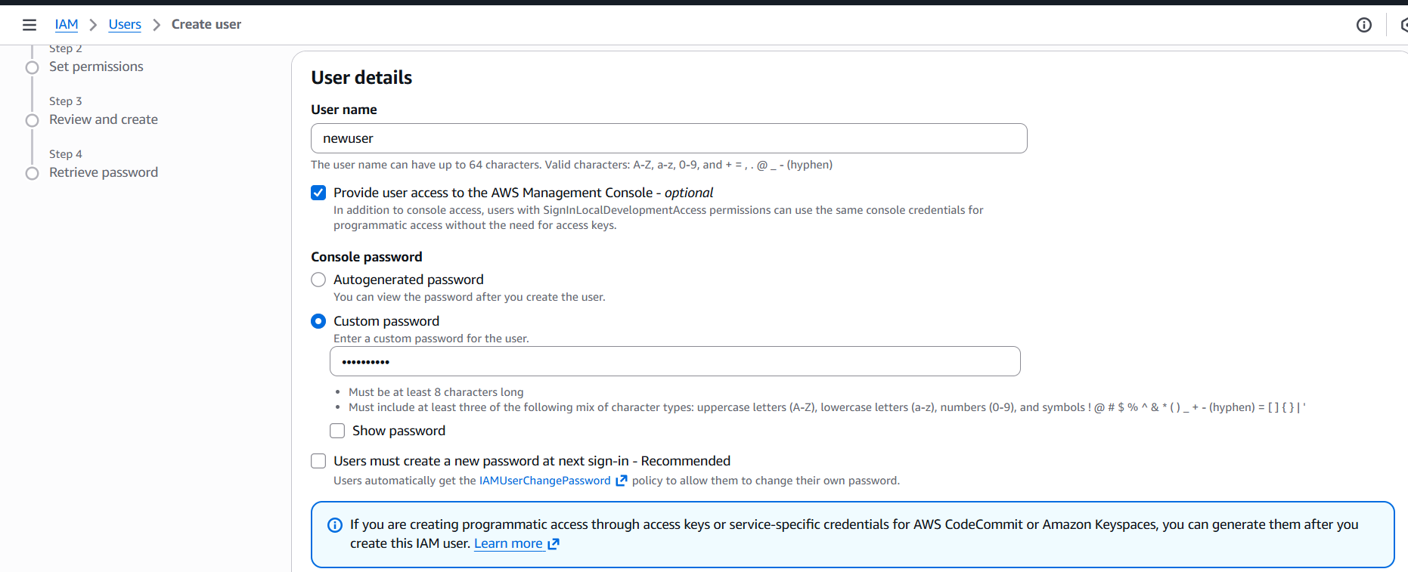
Step 2: Provided S3 full access to the New user
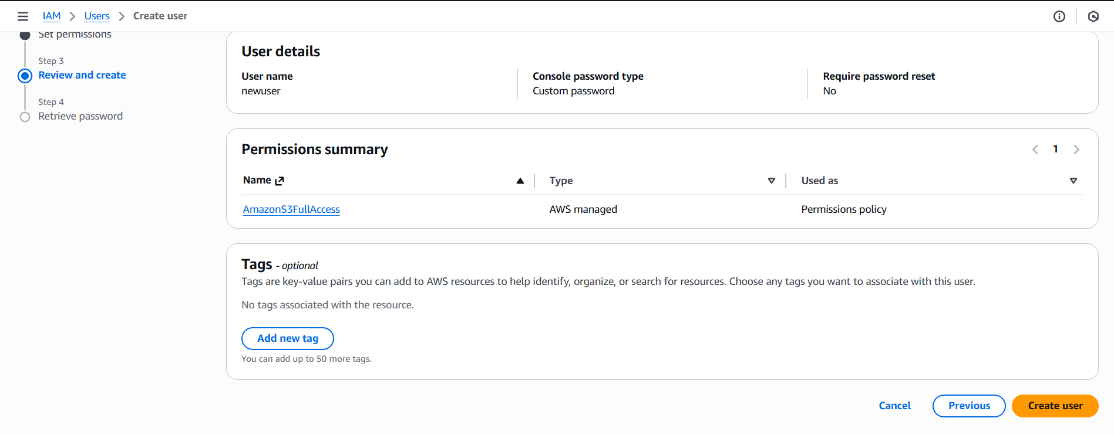
Step 3: the user is able to list the all the buckets
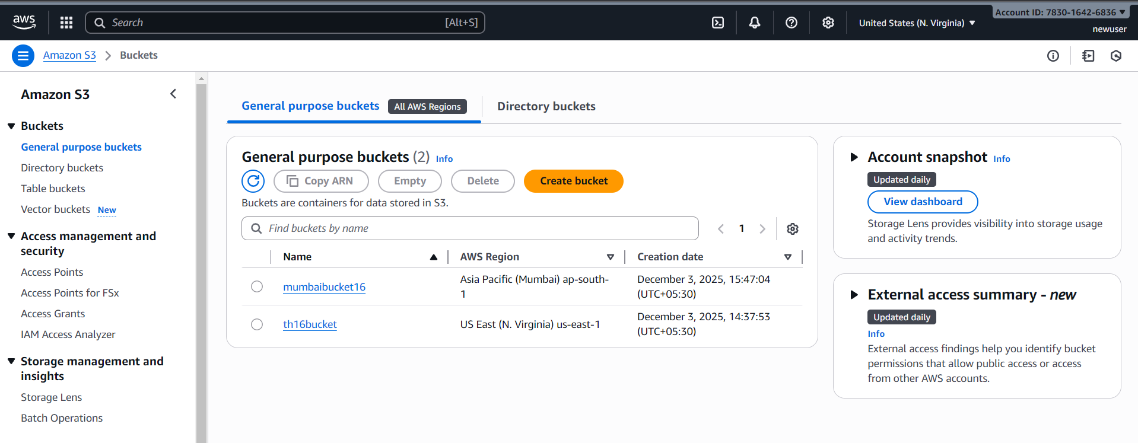
Step 4: But the user cannot access the objects inside of s3 bucket
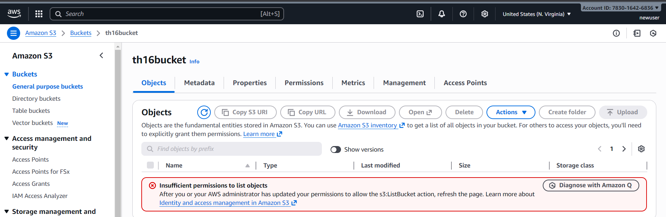
Step 5: But the user can access another bucket objects as well
(we only wrote the JSON script for denying only a specific bucket not all)
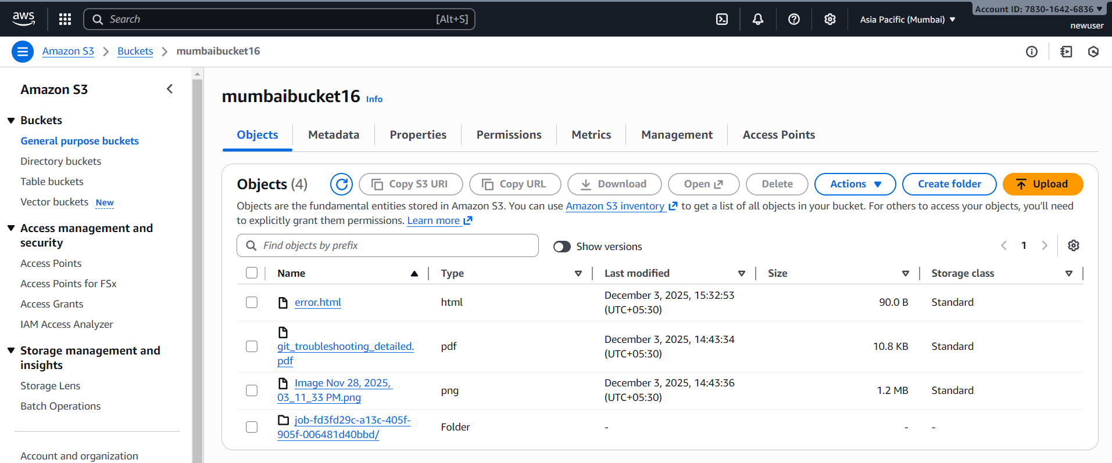

5.Set up lifecycle policies to automatically transition or delete objects based on specific criteria.
Step 1: Navigate to S3 bucket and go to Management Section and select on CREATE LIFECYCLE RULE
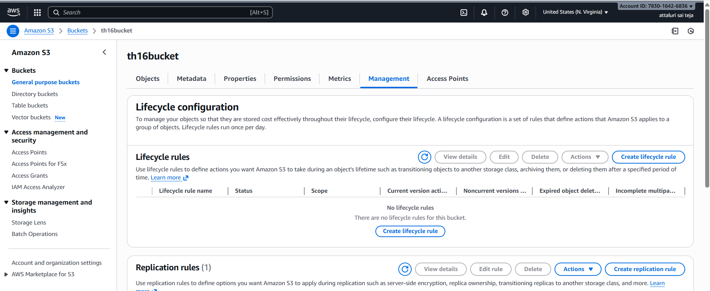
Step 2:Provide a name and I selected the cycle for all buckets
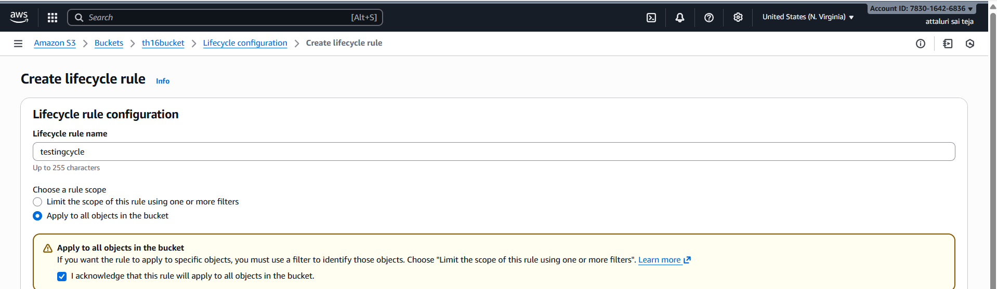
Step 3: In the licycle rule actions select rules accordingly to you
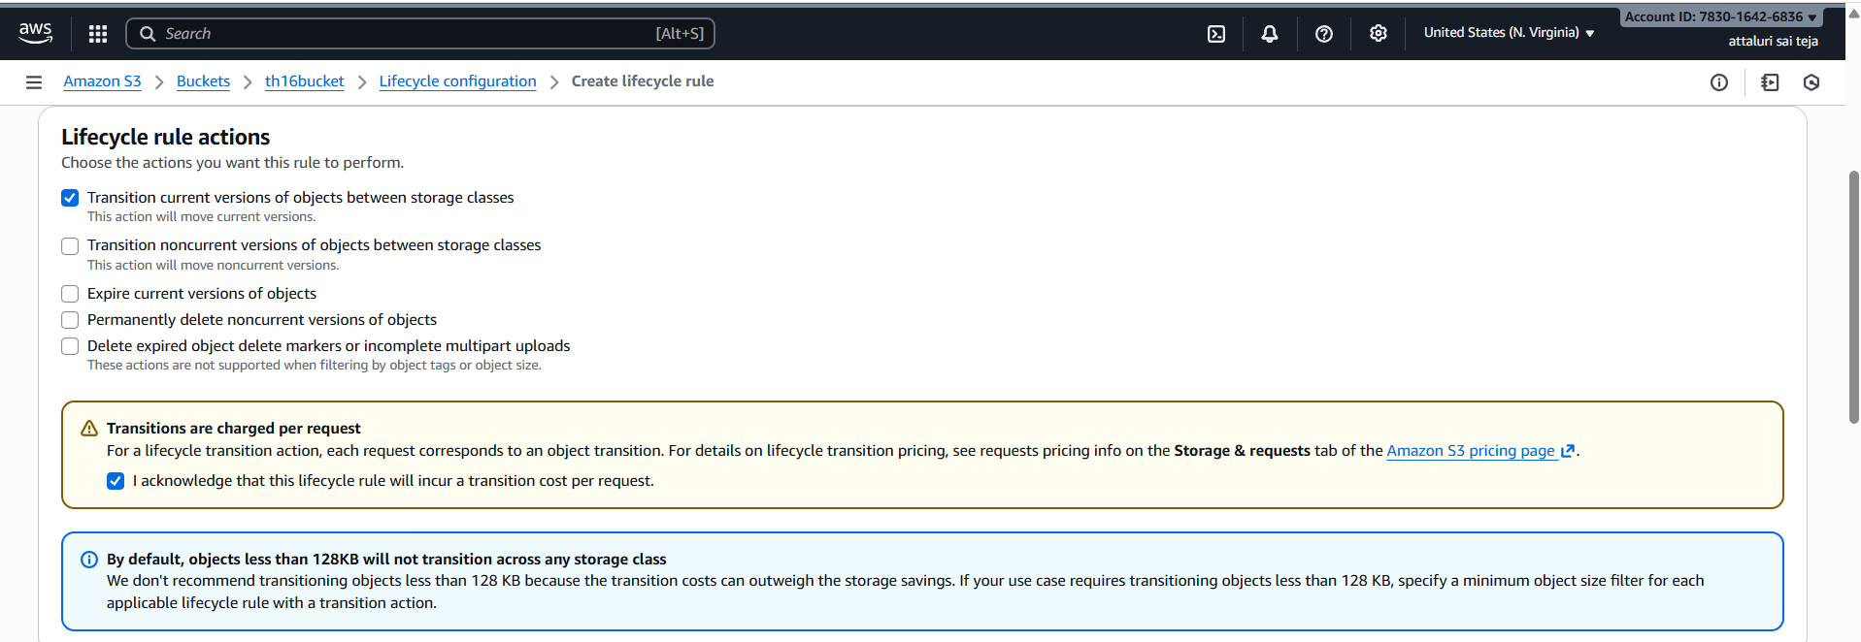

Step 4: Provide the details according to your requirement (after how many days the transition could be happen)
*min 30 days for transition
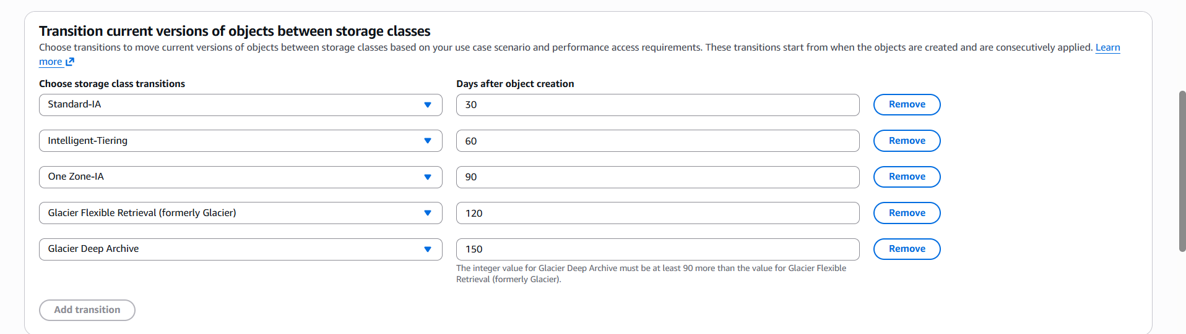
Step 5: Here you can see in the tree view
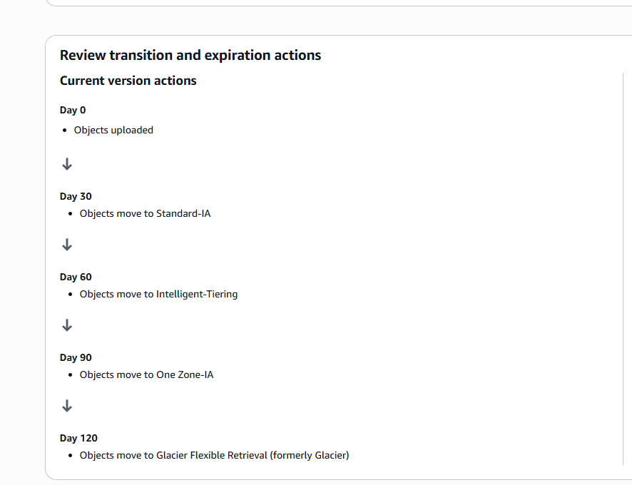

Step 6: Life cycle rules were created successfully
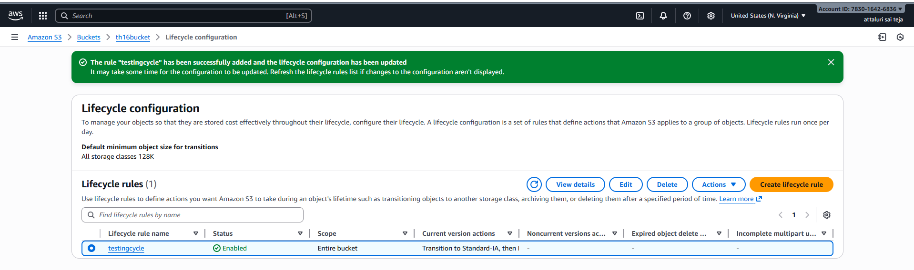
Step 7: Checked the status i.e active or not
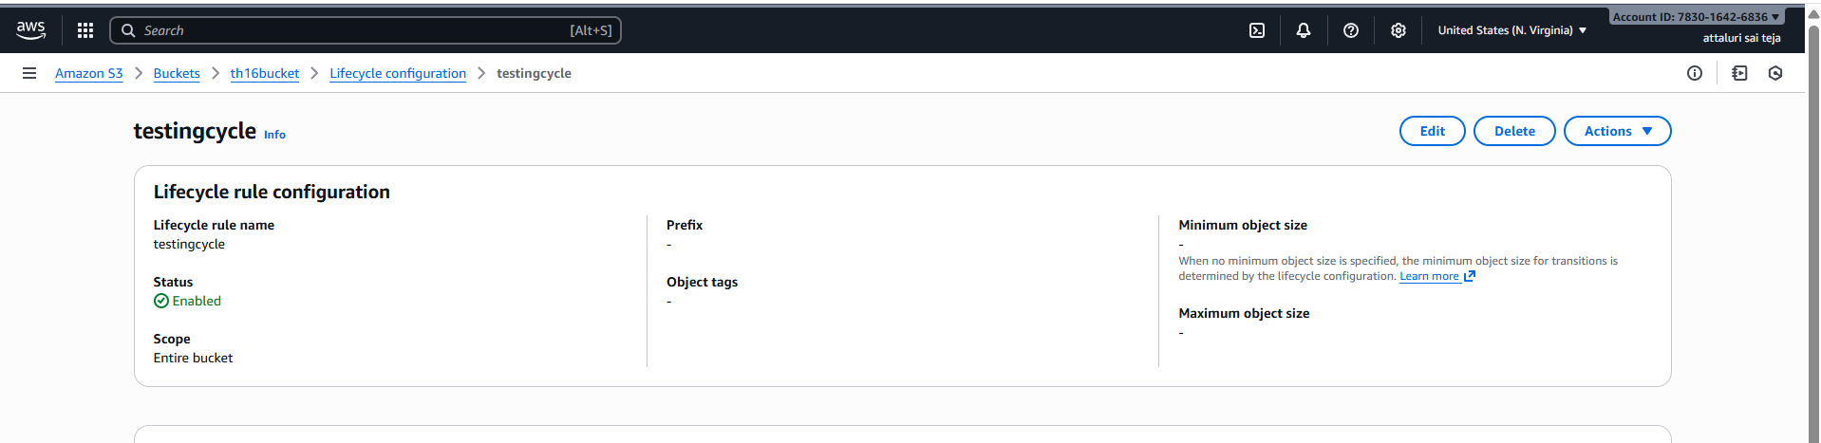
VALIDATION STEPS:
in the particular task we need to wait for 30 days to validate the above task
or transition

6.Push some objects to S3 using the AWS CLI.
These are some commands for aws s3
Command | Description
aws s3 ls | List all S3 buckets associated with your account
aws s3 ls s3://mybucket/ | List files in a specific bucket
aws s3 ls s3://mybucket/ --recursive | List files including subfolders
Command | Description
aws s3 cp file.txt s3://mybucket/ | Upload a file to bucket root
aws s3 cp photo.jpg s3://mybucket/images/ | Upload to a specific folder (prefix)
aws s3 cp docs/ s3://mybucket/docs/ --recursive | Upload entire directory
aws s3 sync localdir/ s3://mybucket/localdir/ | Sync only changed/new local files to S3
Command | Description
aws s3 cp s3://mybucket/file.txt . | Download a single file to current directory
aws s3 cp s3://mybucket/data/ ./data/ --recursive | Download a directory
aws s3 sync s3://mybucket/backup/ ./backup/ | Sync S3 content to local
Command | Description
aws s3 cp s3://source/file.txt s3://dest/file.txt | Copy a file between buckets
aws s3 sync s3://bucket1/ s3://bucket2/ | Sync two buckets
Command | Description
aws s3 rm s3://mybucket/file.txt | Delete a single file
aws s3 rm s3://mybucket/tmp/ --recursive | Delete folder and everything inside
Command | Description
aws s3 cp file.txt s3://mybucket/ --acl public-read | Upload and make file publicly readable
aws s3 cp file.txt s3://mybucket/ --sse AES256 | Upload with server-side encryption
Command | Description
aws s3 rm s3://mybucket/dir/ --recursive --dryrun | Show what would be deleted without actually deleting
** aws configure
Step 1: Create a access key for configuring aws to CLI
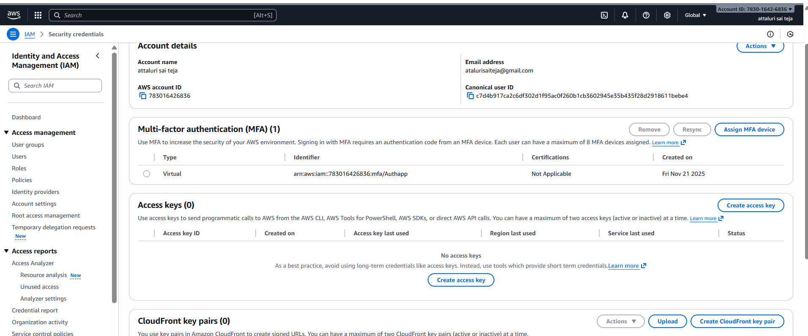

Step 2: Confirm the details and create
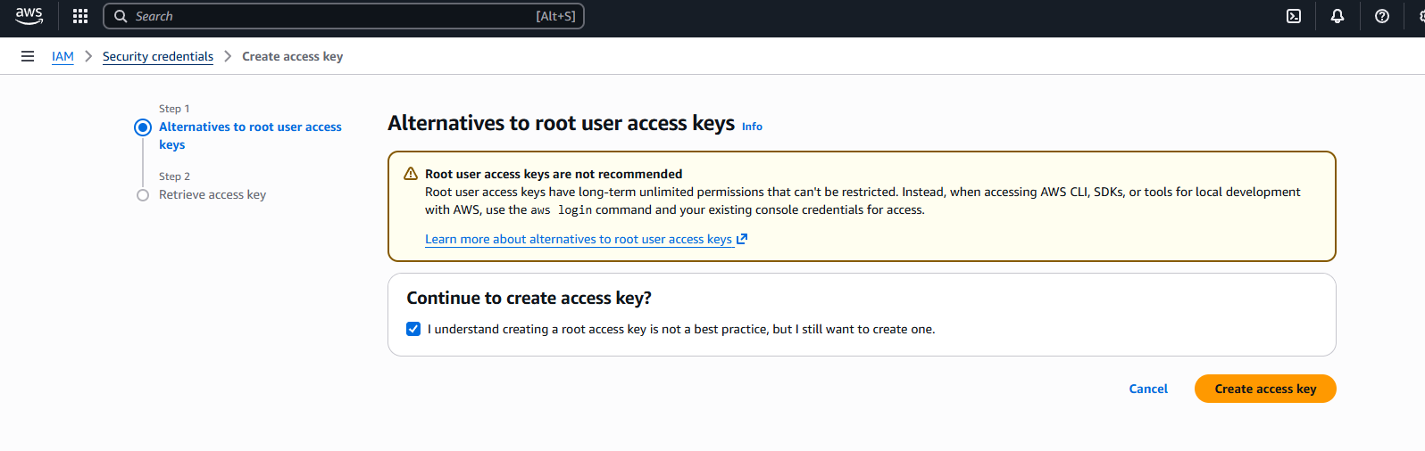
Step 3: Access key created successfully
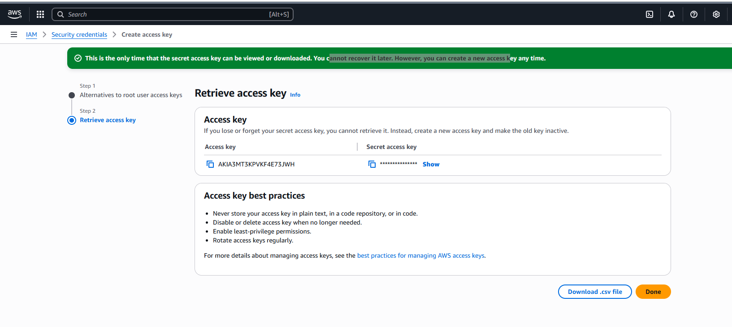
Step 4: using the access key configured in CLI using aws configure command
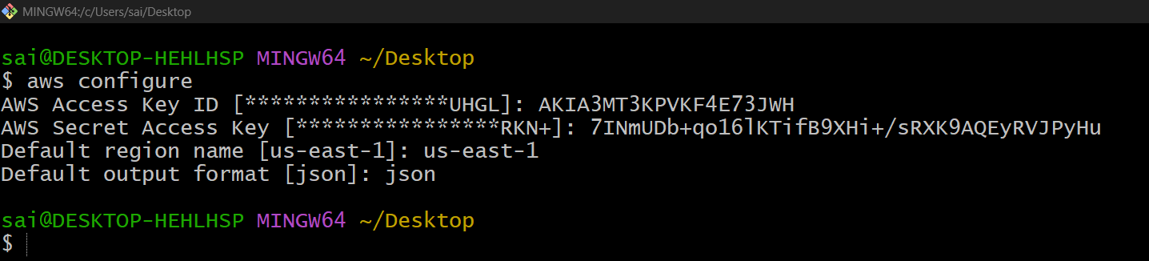
Step 5: listed the buckets in my aws through CLI
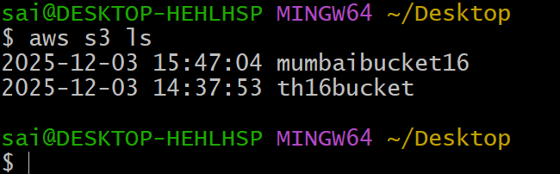
Step 6: taken a screenshot of objects before uploading
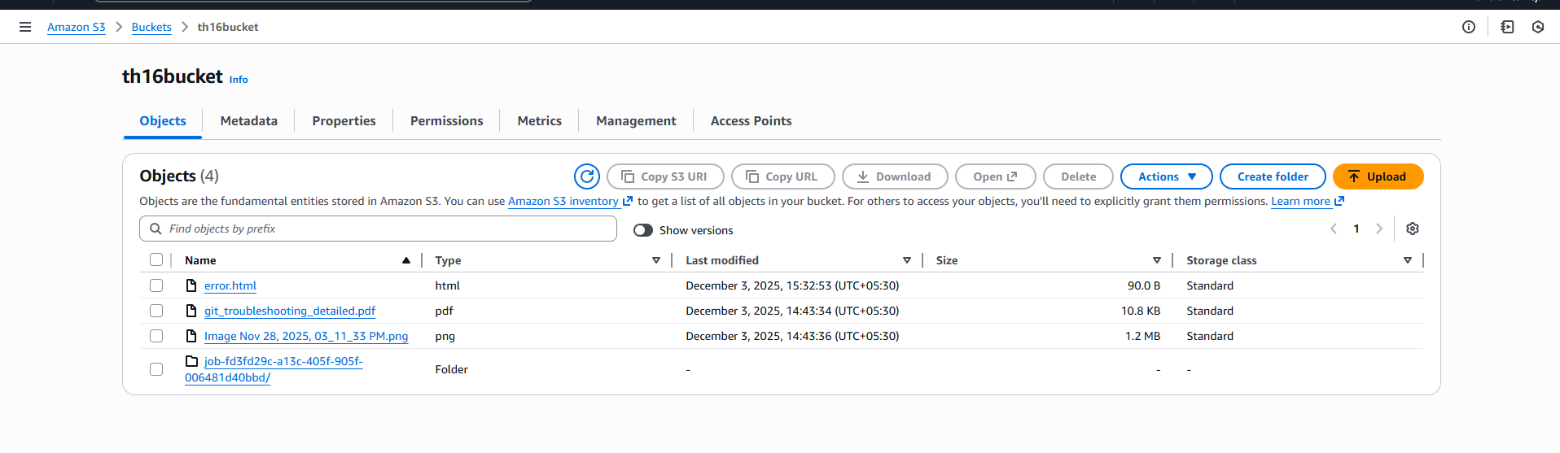
Step 7: use the below command to upload the documents
Only one file uploading at a time
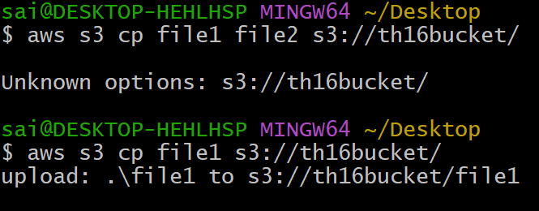
Step 8: again Verified the files which I uploaded
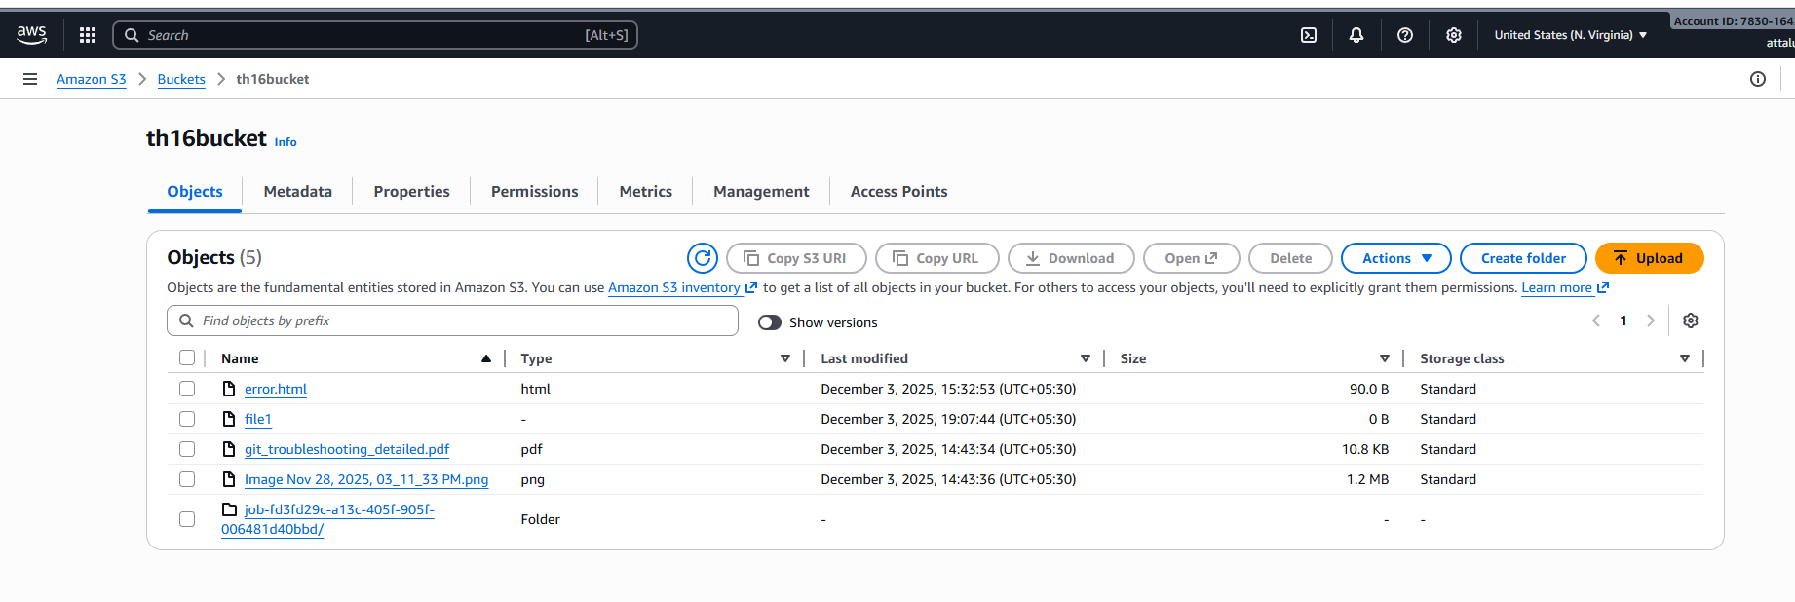
Step 9: again uploaded the another files
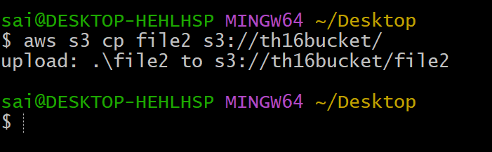
Step 10 : re verified the files
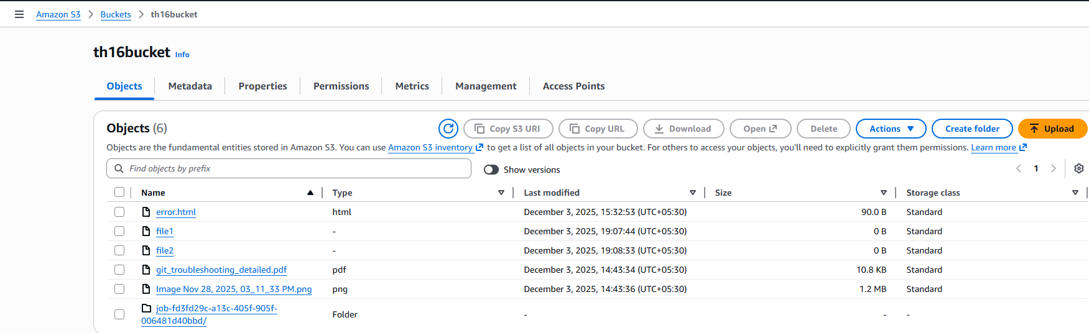

7.Write a Bash script to create an S3 bucket.
Step 1: Write the script in CLI
In the script I allowed only two regions ton create s3 buckets and taken input from user
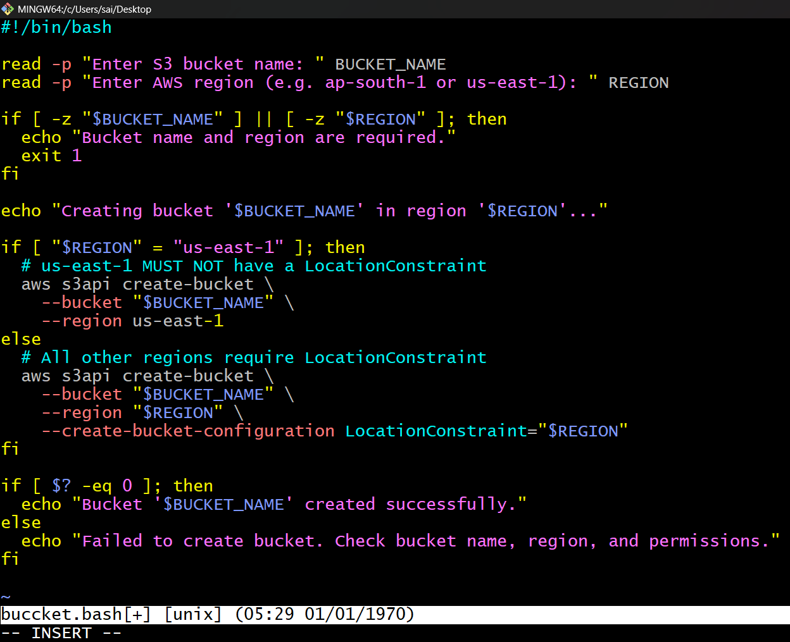
Step 2: Open CLI and create a .bash file for executing script
And provide permissions and execute the task
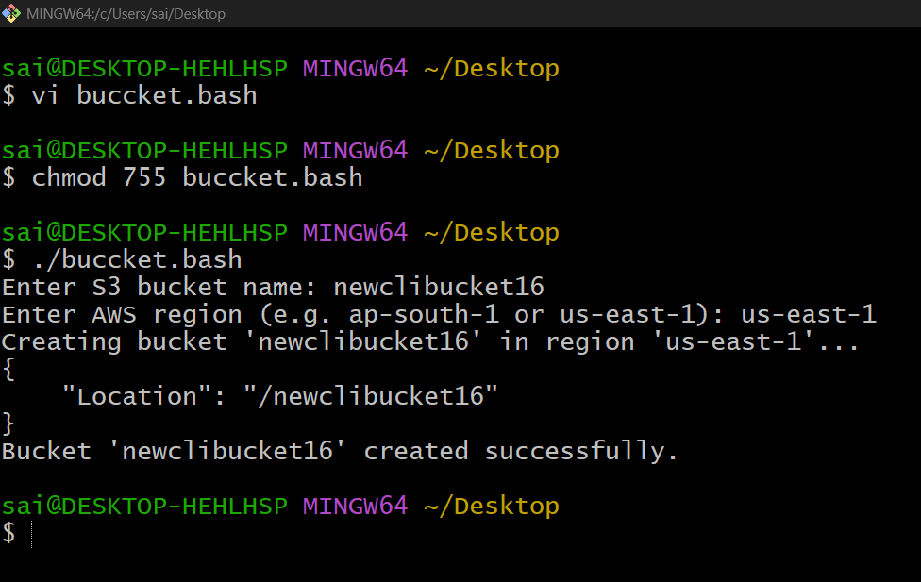
Step 3:Verified in GUI the bucket was created
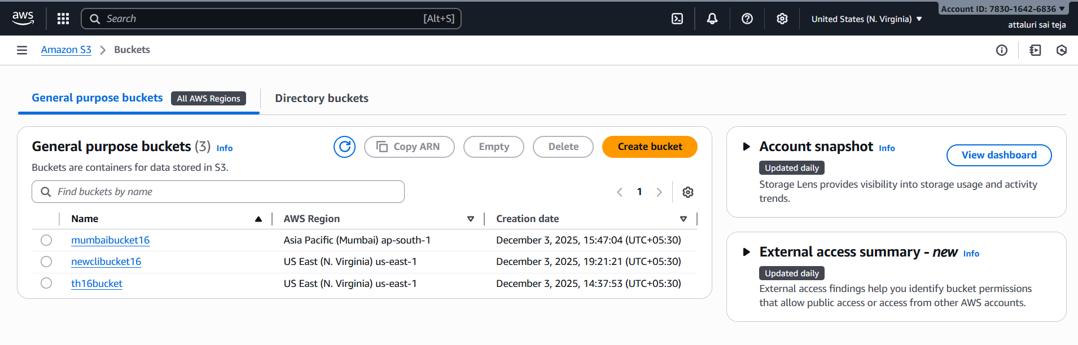

8.Upload a 1 GB file to S3 using the CLI.
Step 1: Created a 1gb file using command
dd if=/dev/zero of=1gbfile.bin bs=1M count=1024
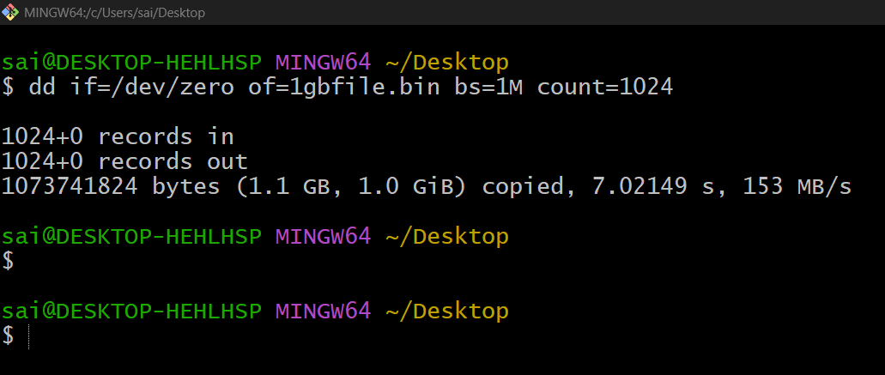
Step 2: listed the files and uploaded the file using command
Aws s3 cp filename s3://bucketname/
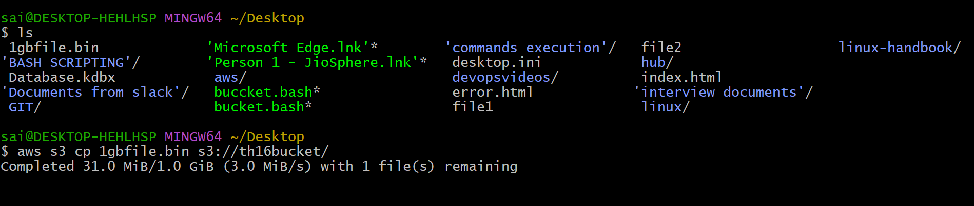
And the uploading was in process
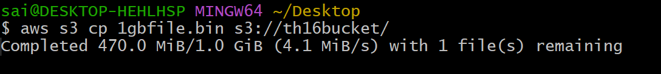
Completed the upload from CLI
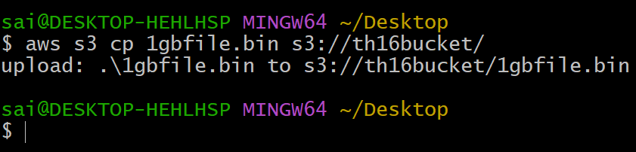
Verified the file in GUI
